<https://www.youtube.com/watch?v=StWY5QWMXCw&list=PLblh5JKOoLUICTaGLRoHQDuF_7q2GfuJF&index=53>



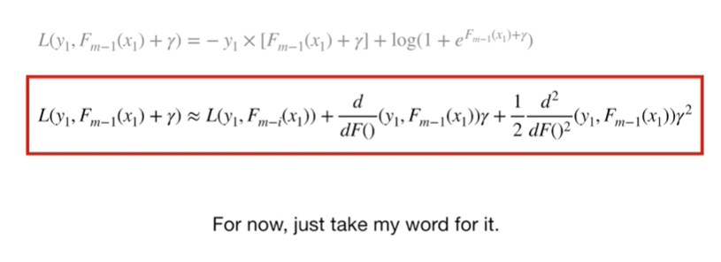

For now just take my word for it.

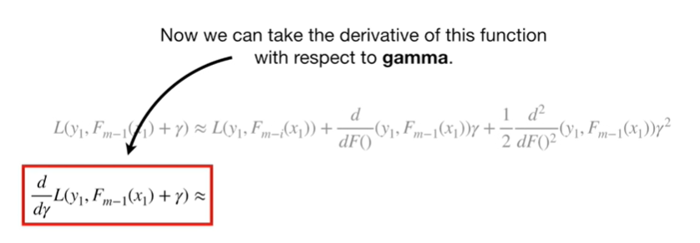

Now we can take the derivative of this function with respect to gamma.

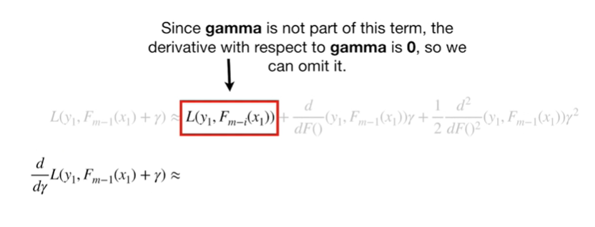

Since gamma is not part of this term the derivative with respect to gamma is 0, so we can omit it.

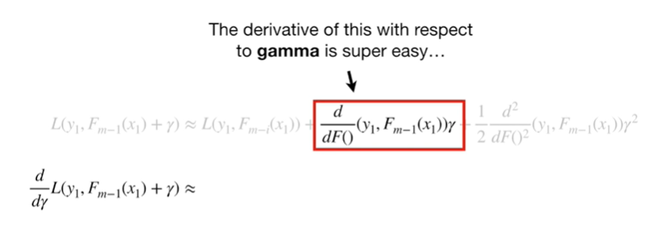

The derivative of this with respect to gamma is super easy

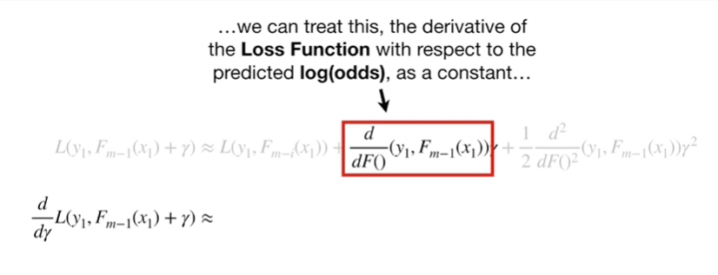

we can treat this the derivative of the loss function with respect to the predicted log-odds as a constant

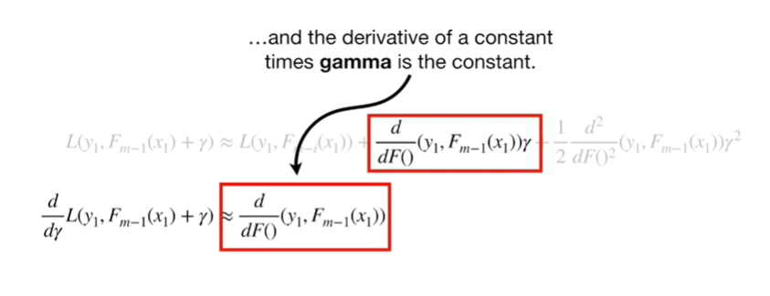

and the derivative of a constant times gamma is the constant.

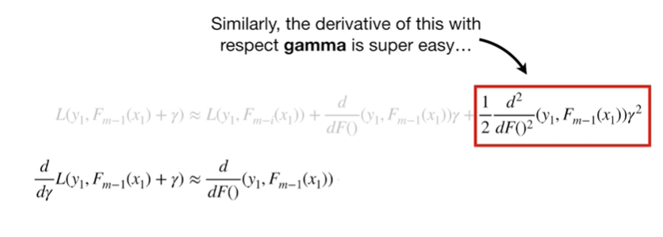

Similarly the derivative of this with respect to gamma is super easy.

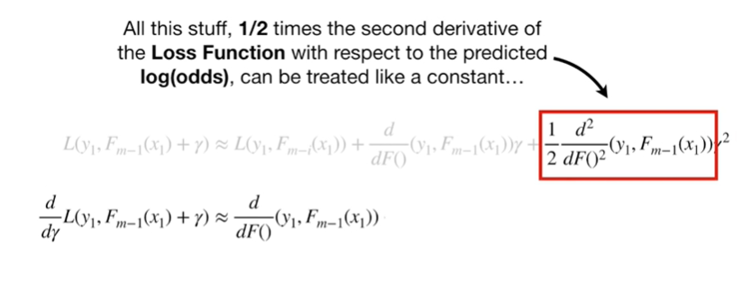

All this stuff one half times the second derivative of the loss function with respect to the predicted log odds can be treated like a constant

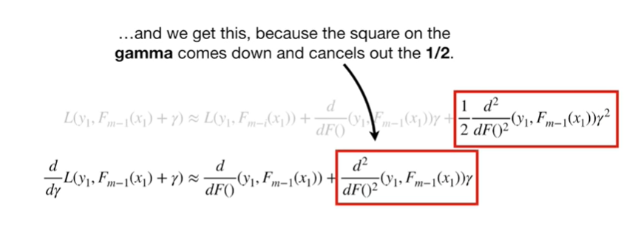

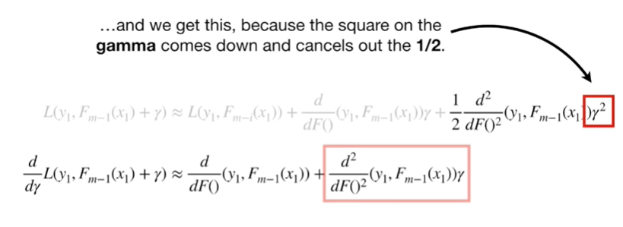

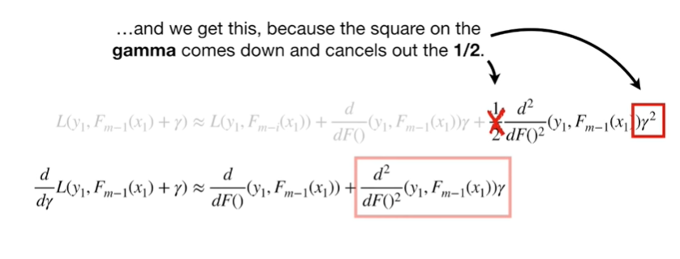

and we get this because the square on the gamma comes down and cancels the ½.

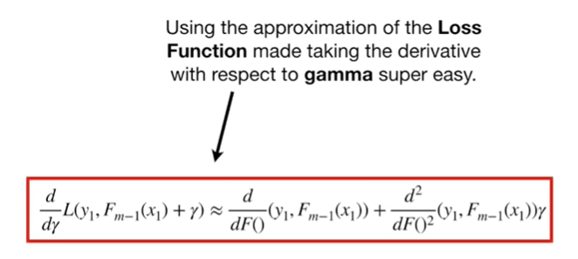

Using the approximation of the loss function made taking the derivative with respect to gamma super easy.

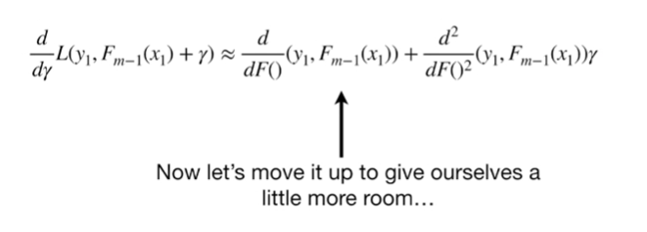

Now let's move it up to give ourselves a little more room

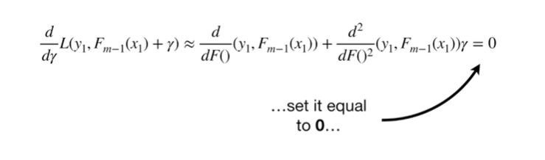

set it equal to zero

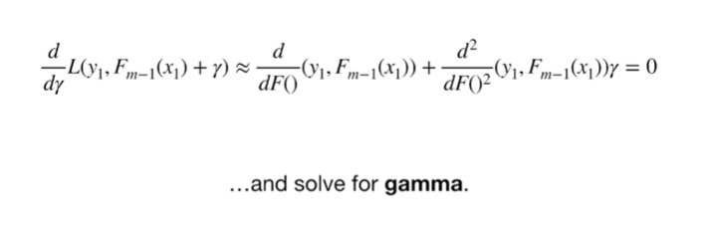

and solve for gamma.

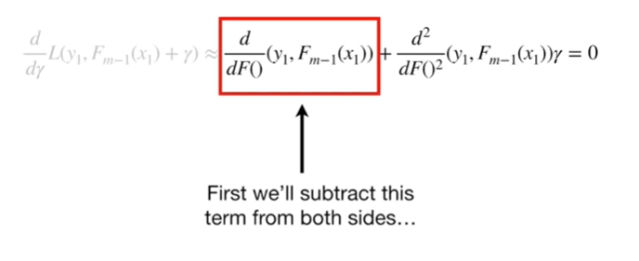

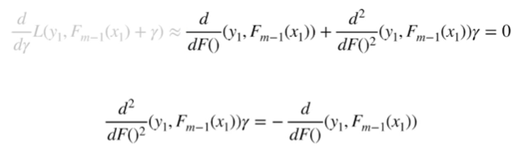

First we'll subtract this term from both sides

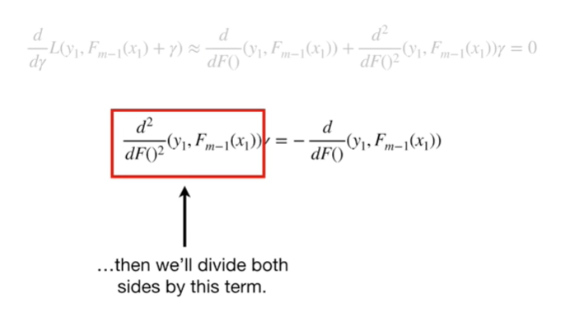

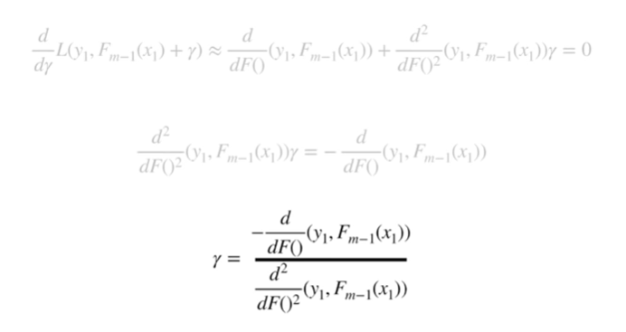

then we'll divide both sides by this term.

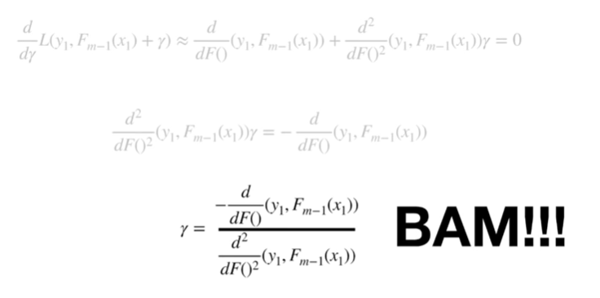

BAM !

We solve for gamma.

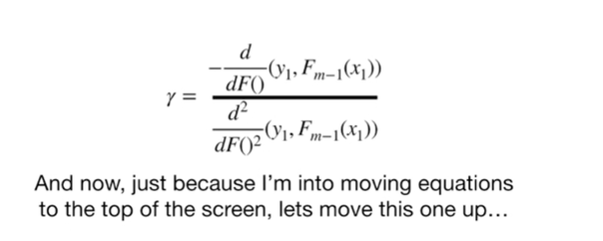

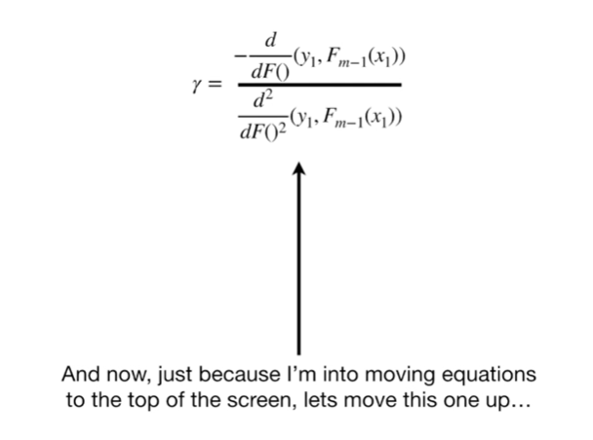

And now, just because I'm into moving equations to the top of the screen, let's move this one up

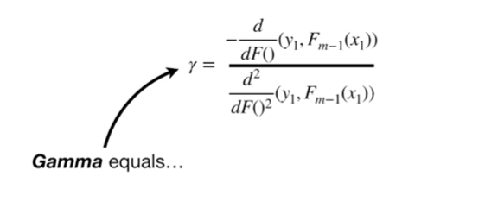

Gamma equals

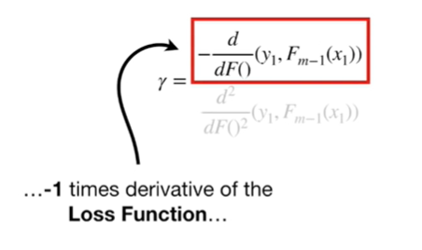

negative 1 times the derivative of the loss function

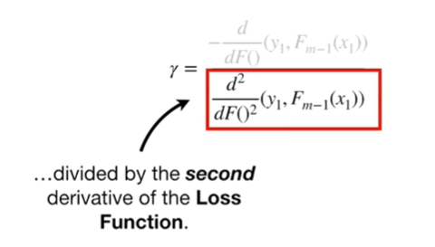

divided by the second derivative of the loss function.

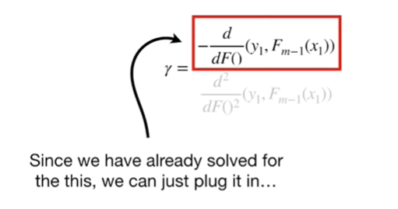

Since we have already solved for this

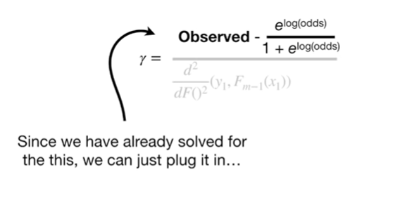

we can just plug it in

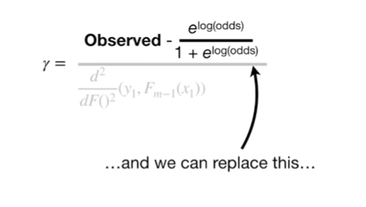

and we can replace this

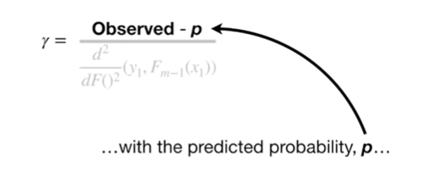

with the predicted probability P

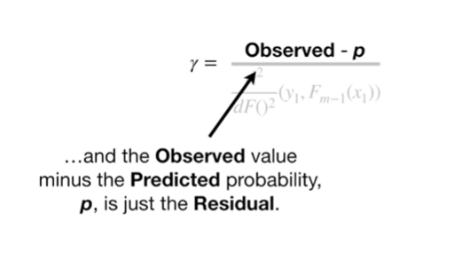

and the observed value minus the predicted probability P, is just the residual.

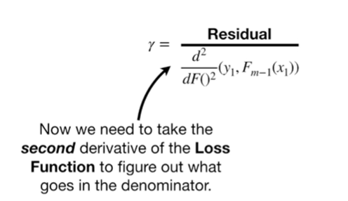

Now we need to take the second derivative of the loss function to figure out what goes in the denominator.

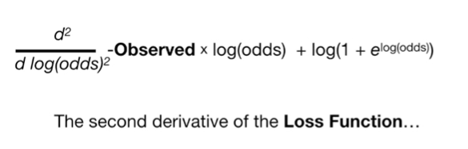

The second derivative of the loss function

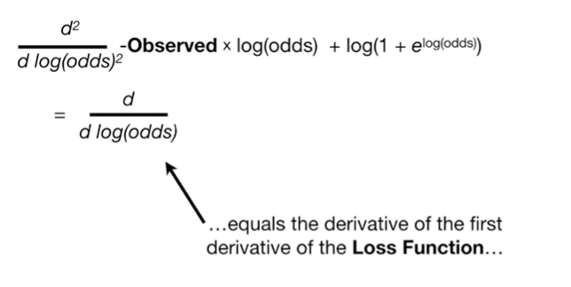

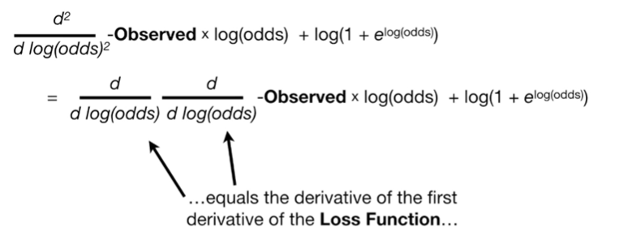

equals the derivative of the first derivative of the loss function

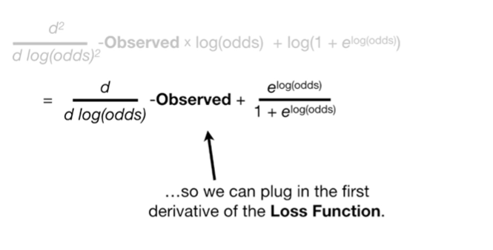

so we can plug in the first derivative of the loss function.

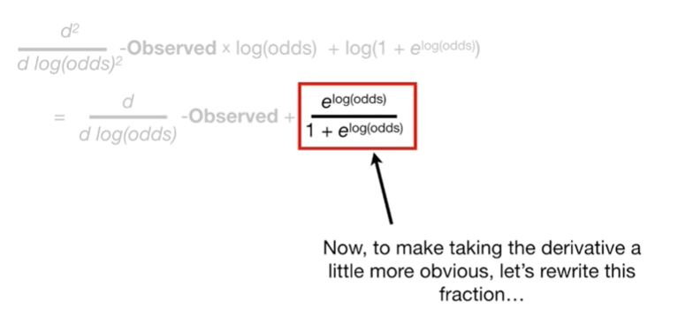

Now to make taking the derivative a little more obvious let's rewrite this fraction

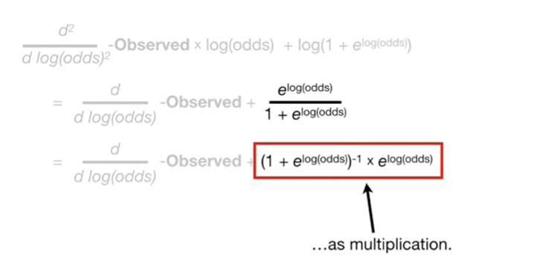

as multiplication.

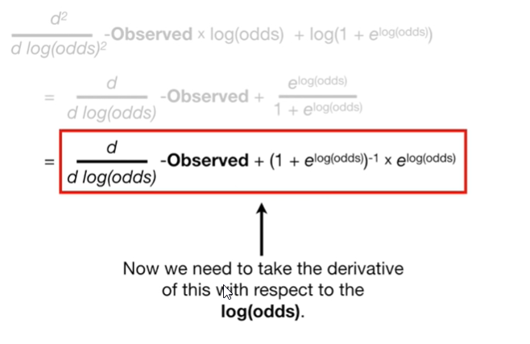

Now we need to take the derivative of this with respect to the log-odds.

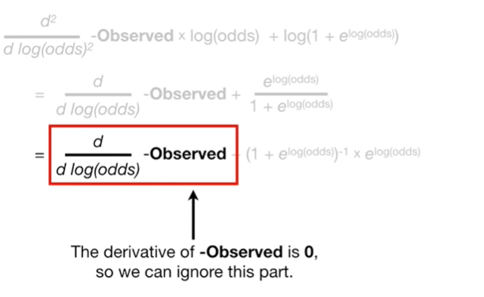

The derivative of negative observed is zero so we can ignore this part.

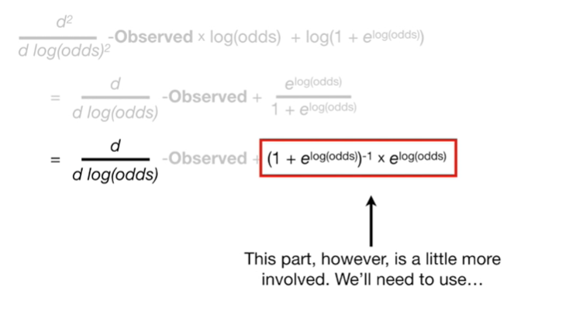

This part, however, is a little more involved.

We'll need to use



the product rule.

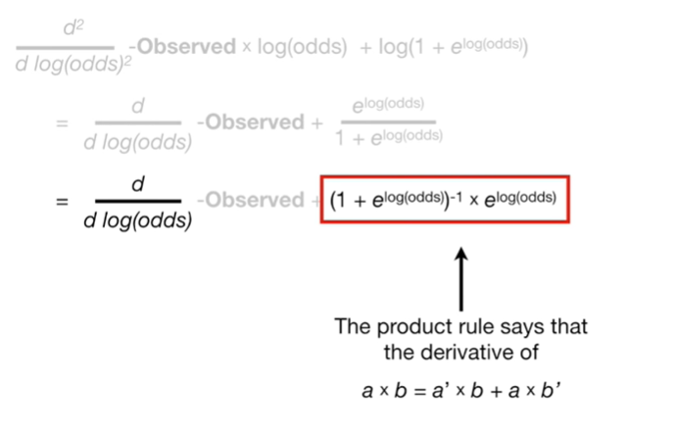

The product rule says that the derivative of a times B equals the derivative of a times B plus a times the derivative of B.

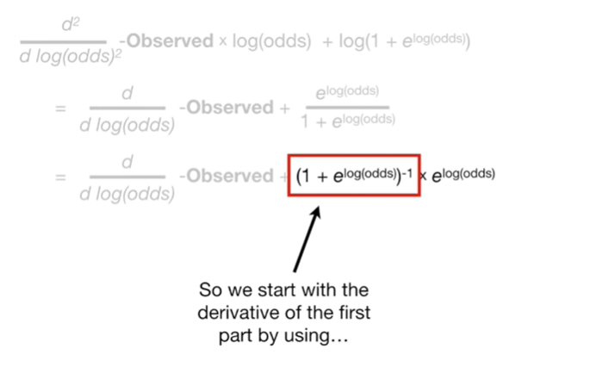

So we start with the derivative of the first part by using



the chain rule

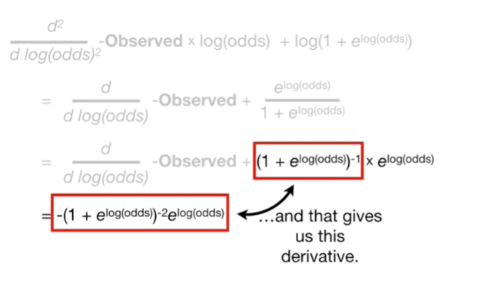

and that gives us this derivative

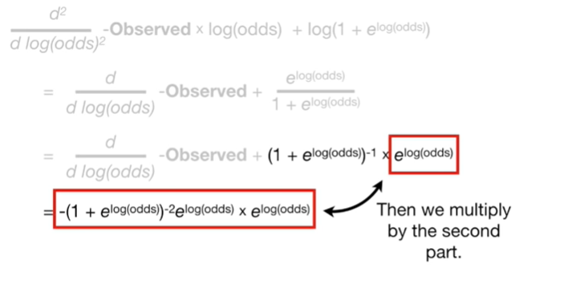

then we multiply by the second part

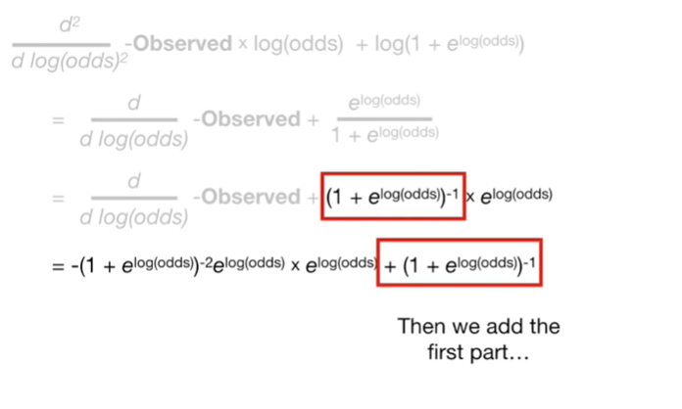

then we add the first part

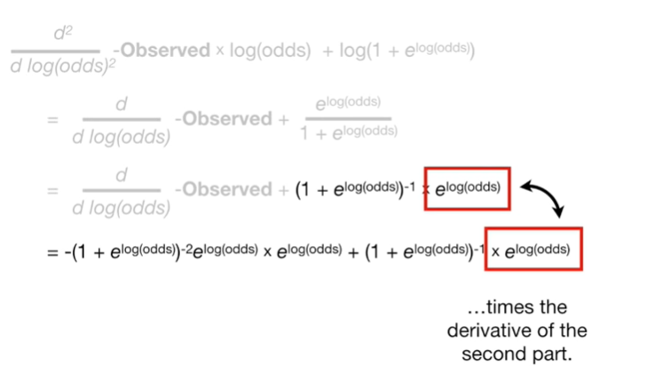

times the derivative of the second part.

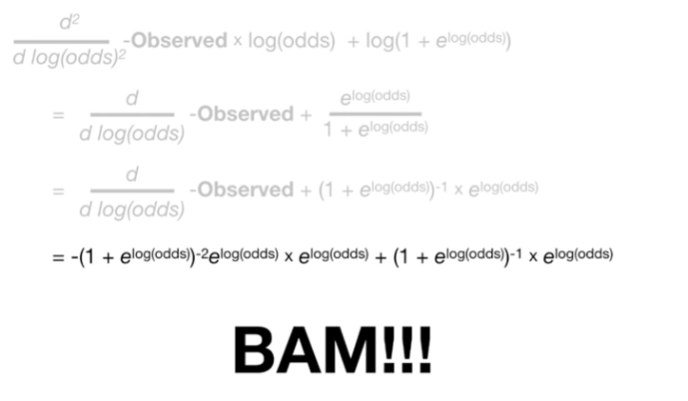

BAM !!!

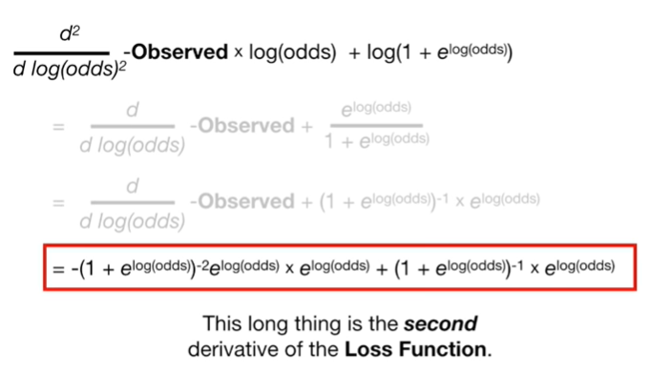

This long thing is the second derivative of the loss function.

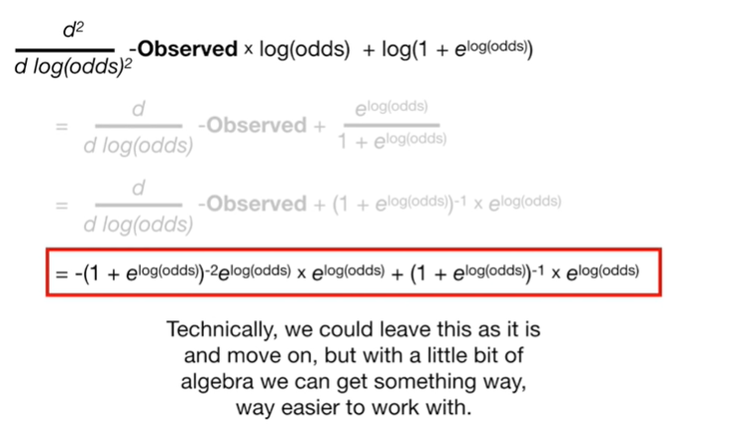

Technically, we could leave this as it is and move on, but with a little bit of algebra we can get something way, way easier to work with.

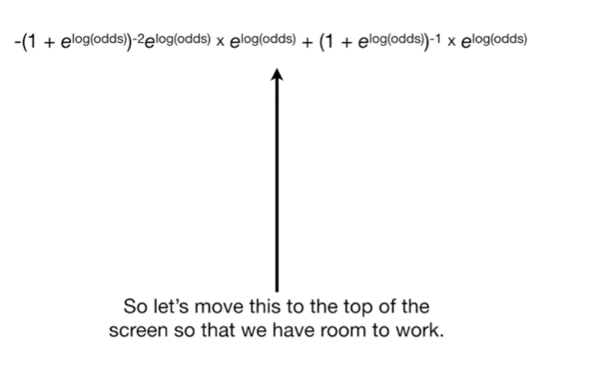

So let's move this to the top of the screen so that we have room to work.

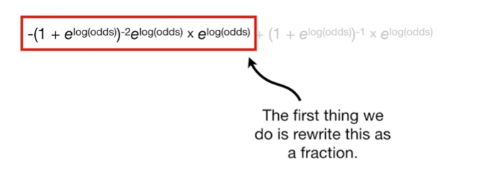

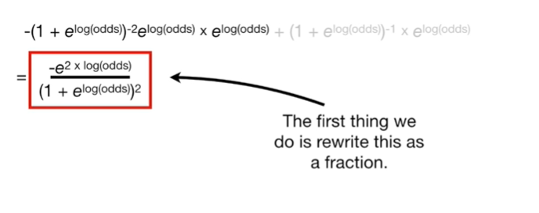

The first thing we do is rewrite this as a fraction

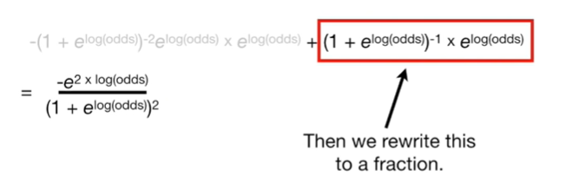

then we rewrite this as a fraction.

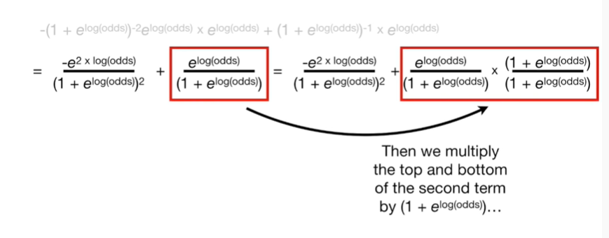

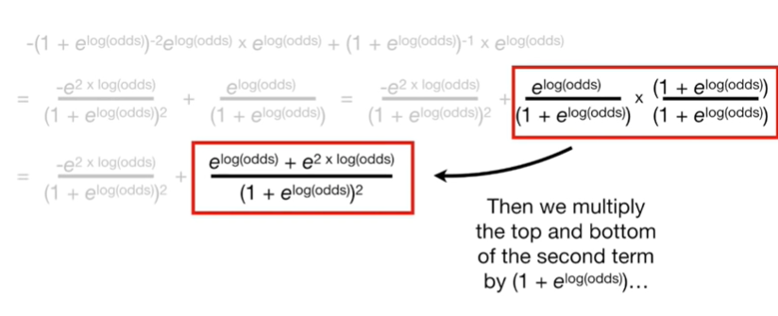

Then we multiply the top and bottom of the second term by 1 plus e to the log odds

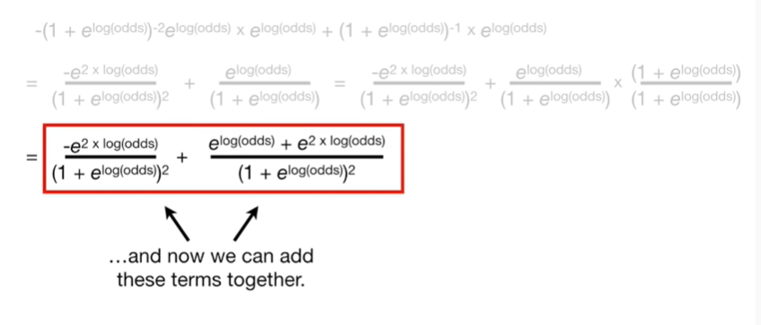

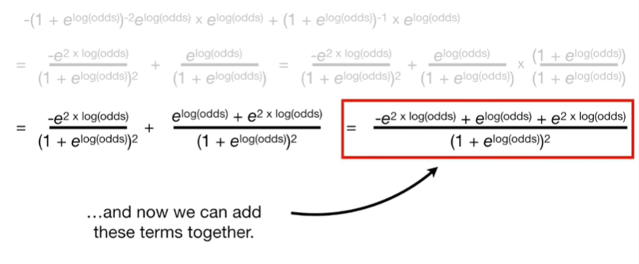

and now we can add these terms together.

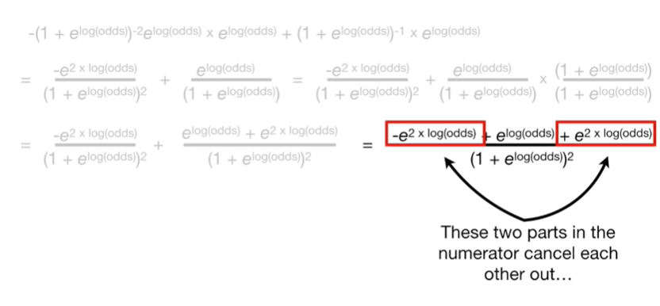

These two parts in the numerator cancel each other out

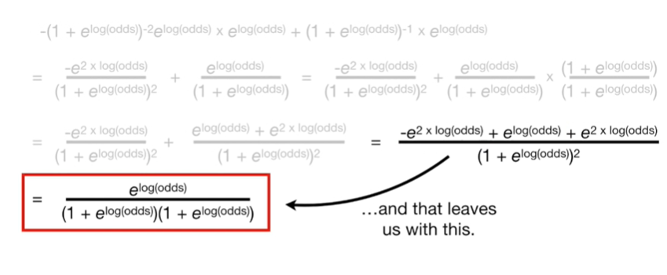

and that leaves us with this.

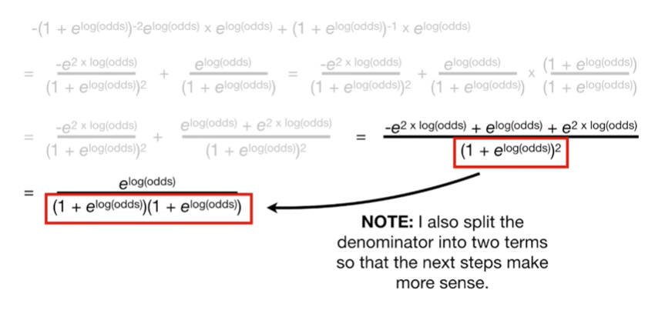

Note : I also split the denominator into two terms so that the next steps make more sense.

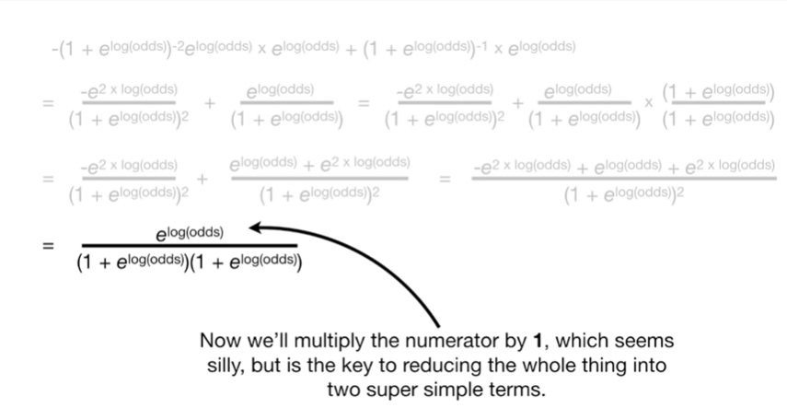

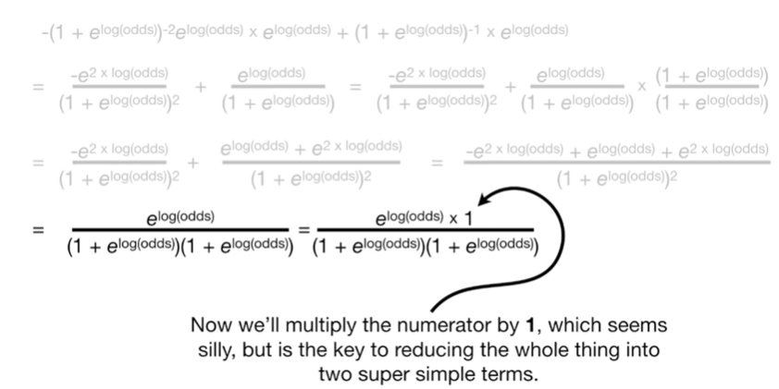

Now we'll multiply the numerator by 1, which seems silly, but is the key to reducing the whole thing into two super simple terms.

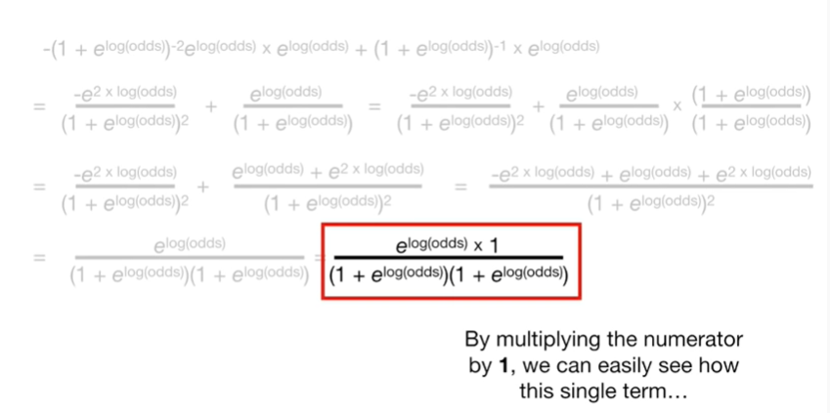

By multiplying the numerator by 1 we can easily see how the single term

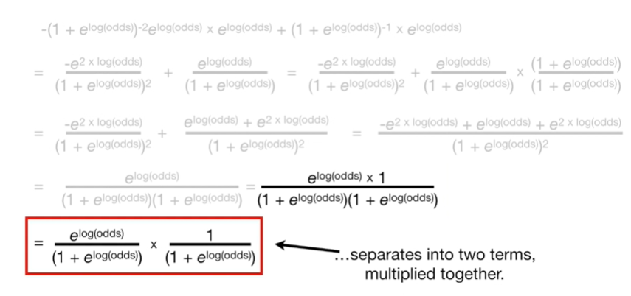

separates into two terms multiplied together.

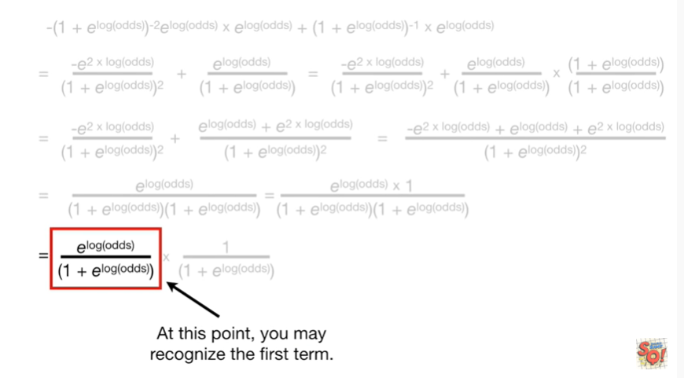

At this point you may recognize the first term.

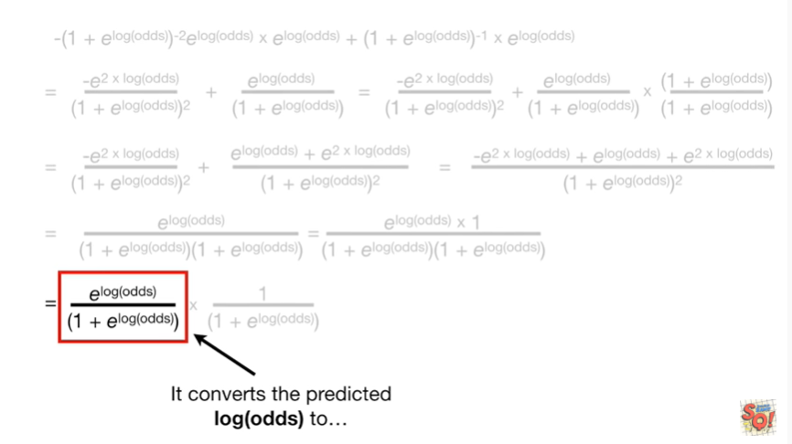

It converts the predicted log odds to

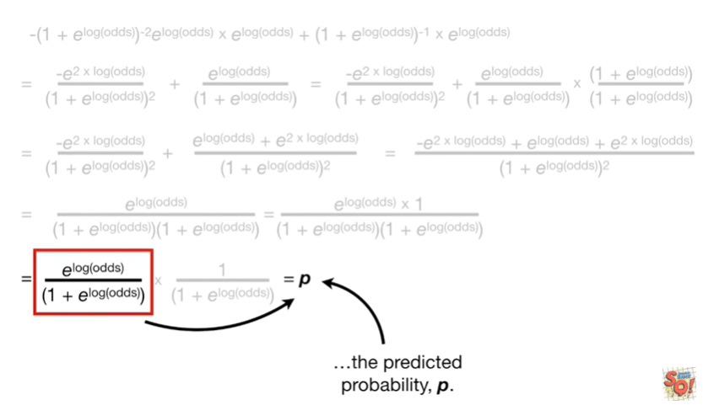

the predicted probability P.

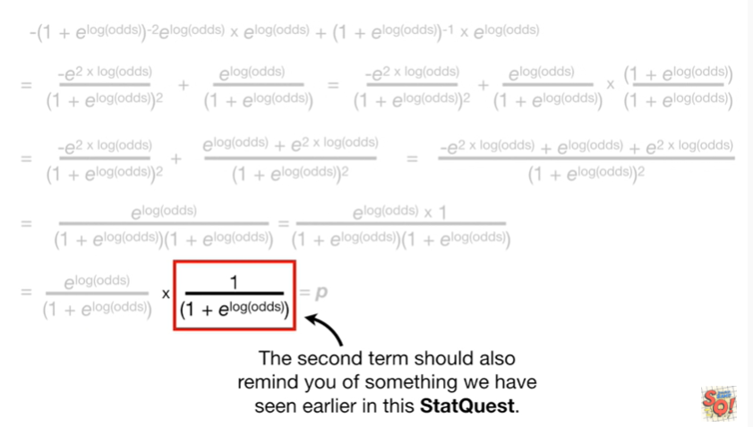

The second term should also remind you of something we have seen earlier in this stat quest.

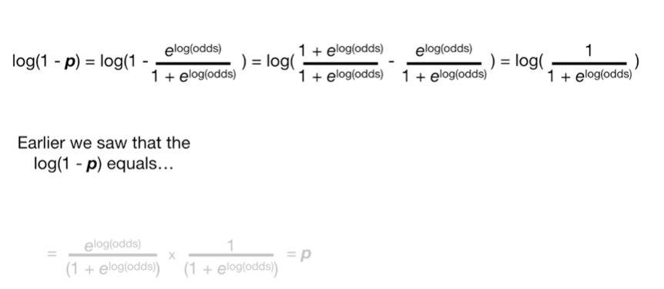

Earlier we saw that the log of 1 minus P equals this

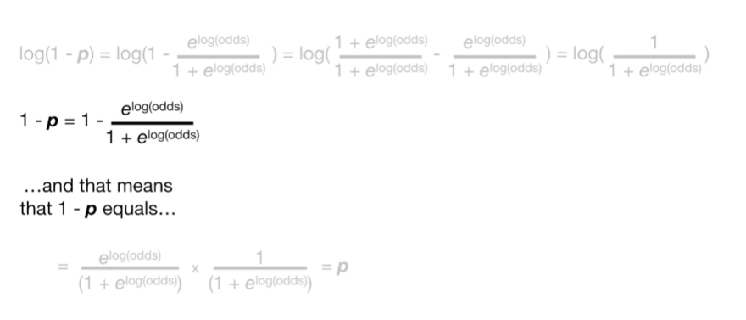

and that means that 1 minus P equals

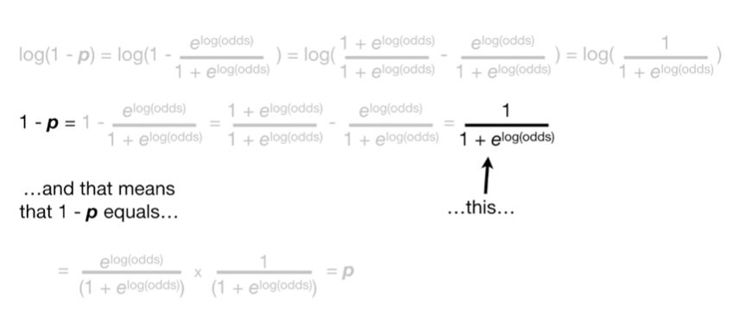

this

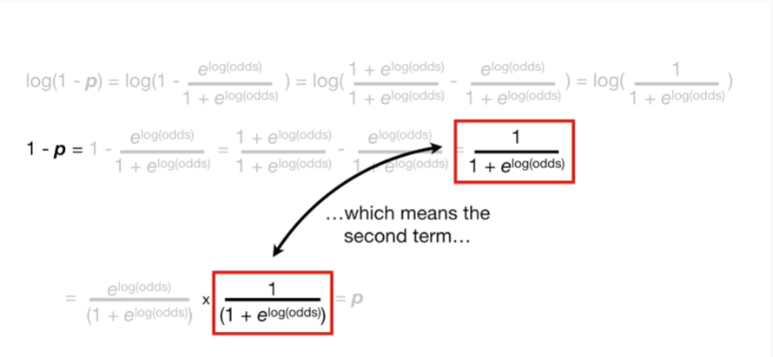

which means the second term

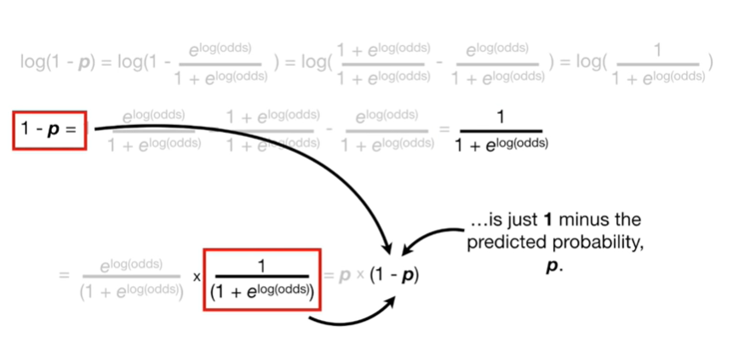

is just 1 minus the predicted probability P.

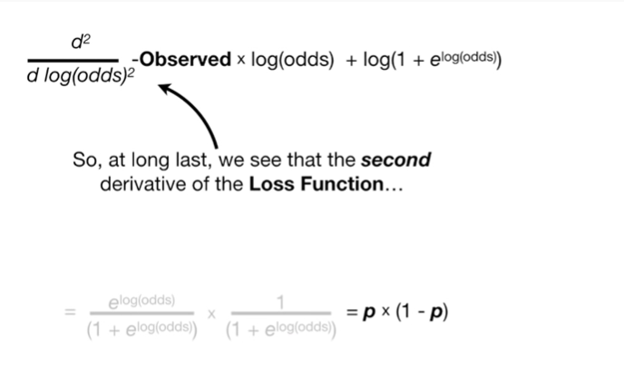

So, at long last, we see that the second derivative of the loss function

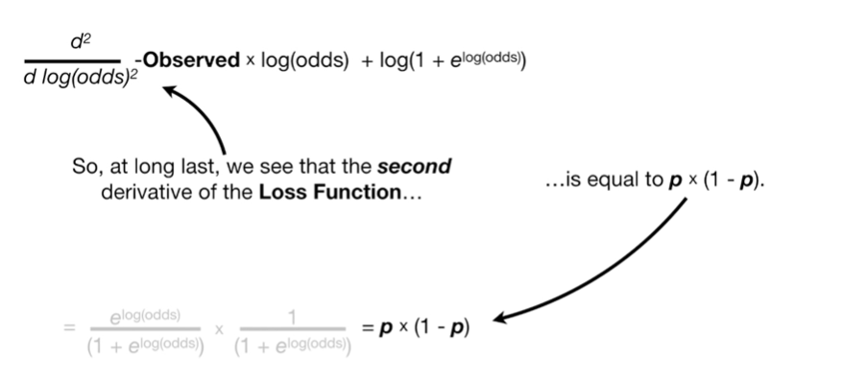

is equal to P times 1 minus P

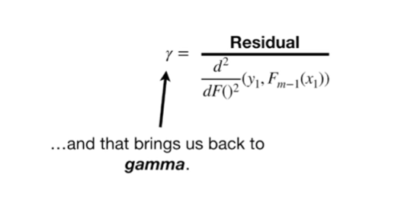

and that brings us back to gamma.

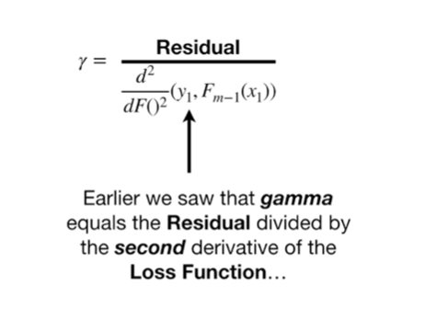

Earlier we saw that gamma equals the residual divided by the second derivative of the loss function

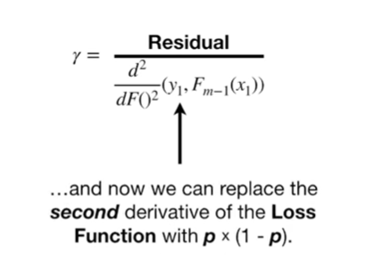

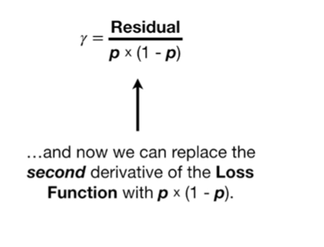

and now we can replace the second derivative of the loss function with P times 1 minus P.

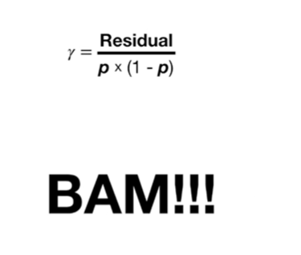

BAM !!!

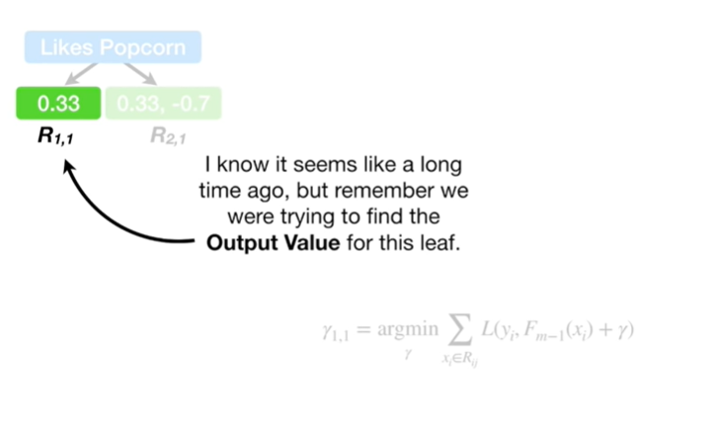

I know it seems like a long time ago, but remember we were trying to find out the output value for this leaf.

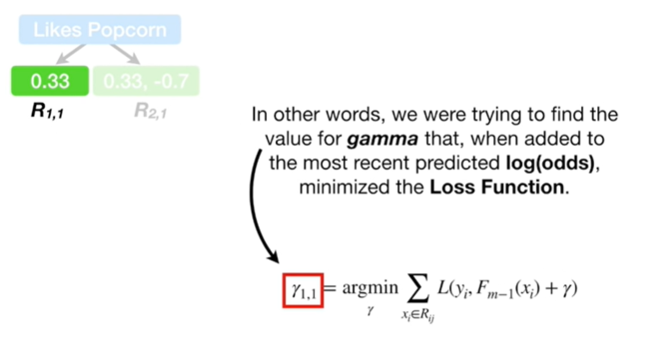

In other words, we were trying to find the value for gamma that, when added to the most recent predicted log odds minimized the loss function.

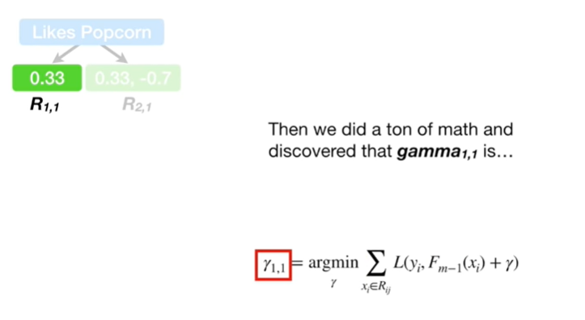

Then we did a ton of math and discovered the gamma sub 1 comma 1 is

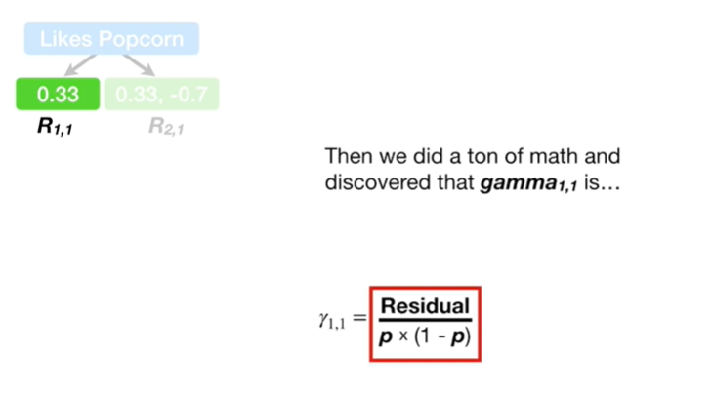

the residual divided by P times 1 minus P.

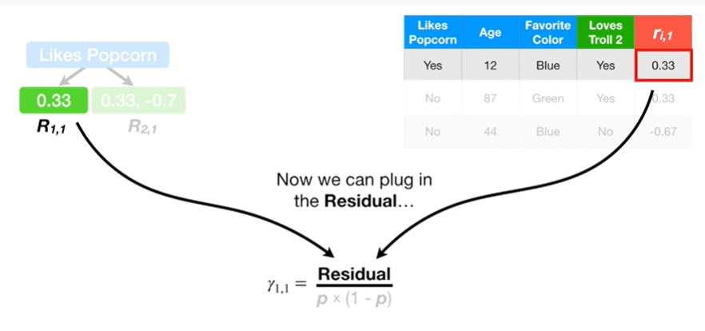

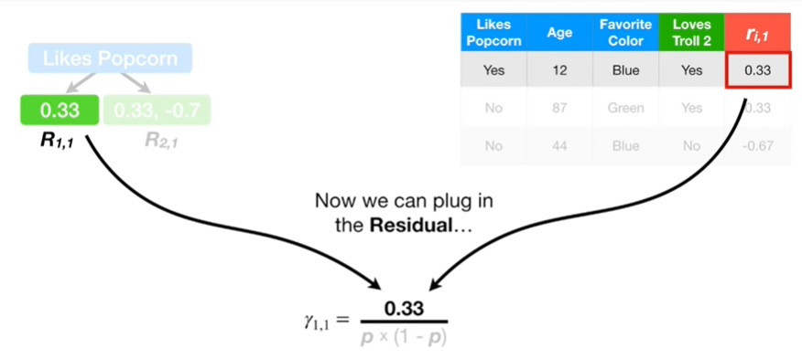

Now we can plug in the residual

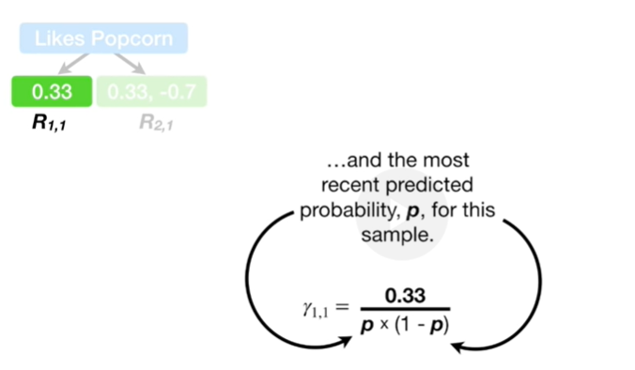

and the most recent predicted probability P for this sample.

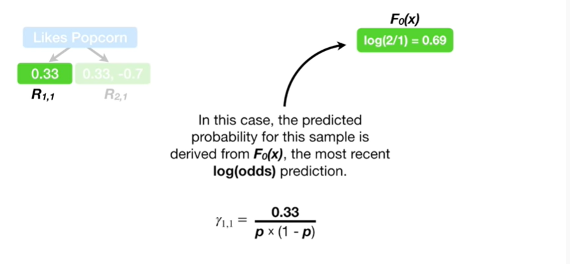

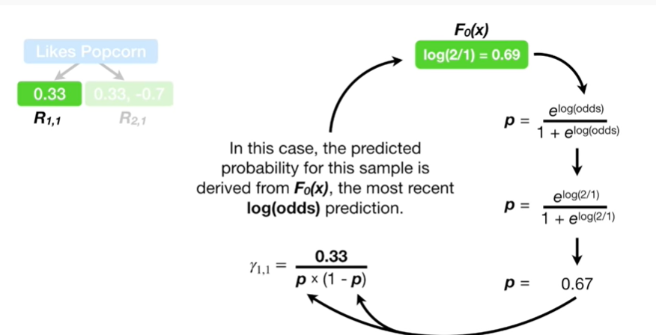

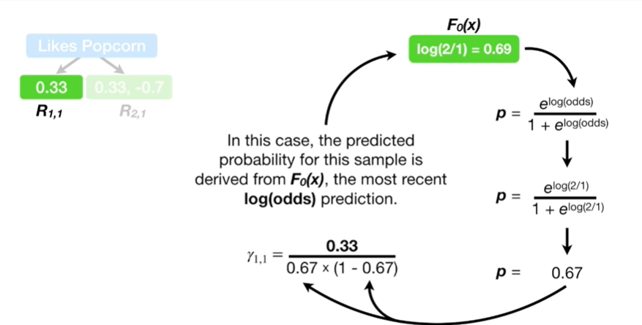

In this case, the predicted probability for this sample is derived from F sub 0 of X the most recent log-odds prediction.

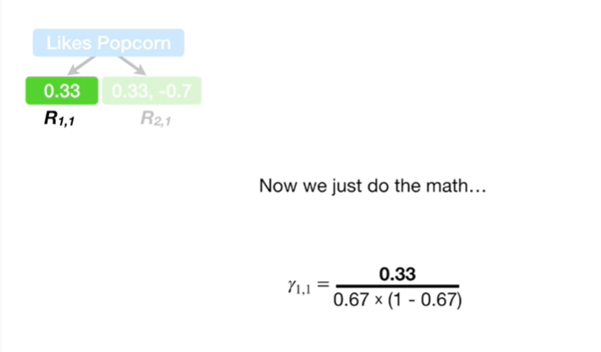

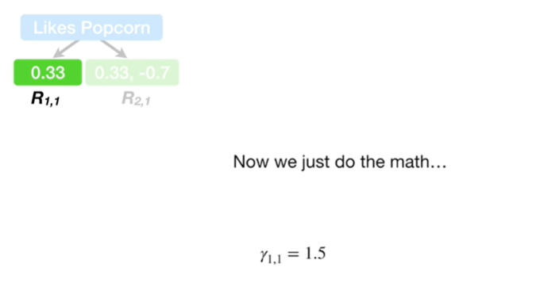

Now we just do the math

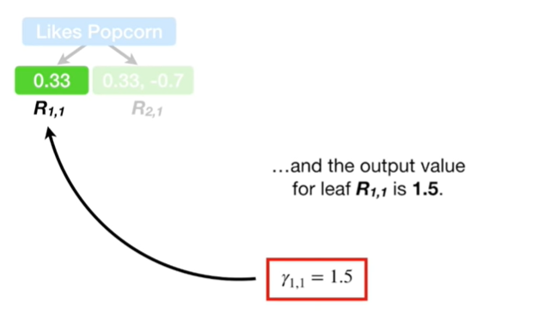

and the output value for leaf R sub 1 comma 1 is 1.5.

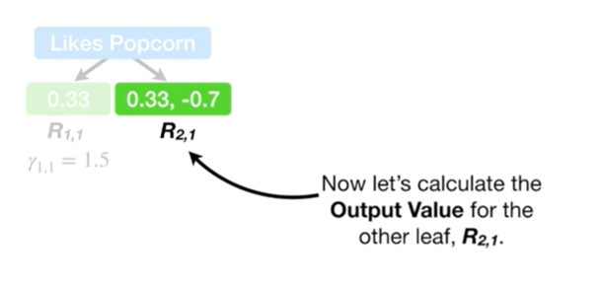

Now let's calculate the output value for the other leaf R sub 2 comma 1.

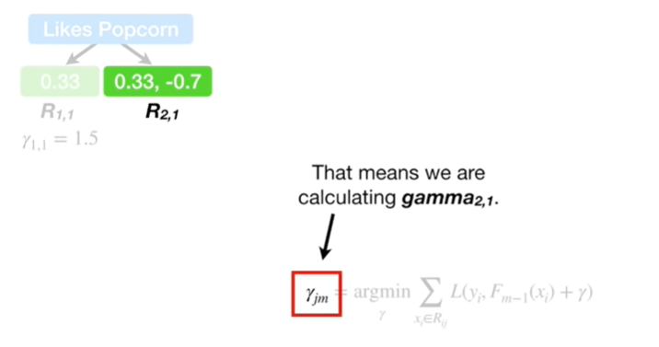

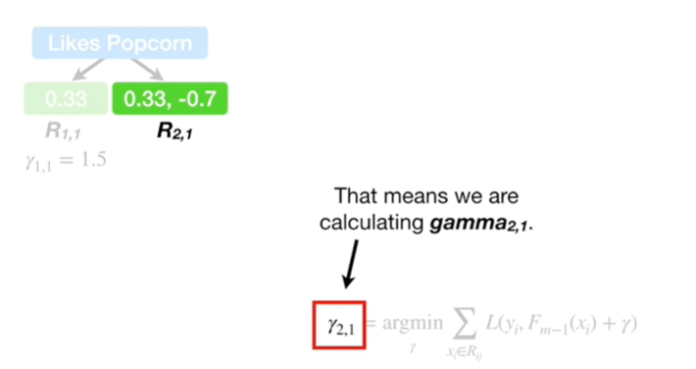

That means we're calculating gamma sub 2 comma 1.

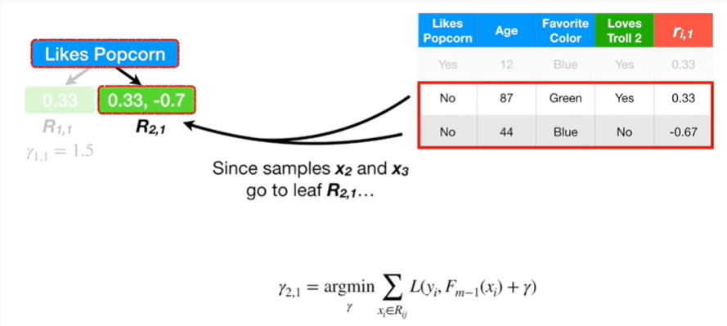

Since samples x 2 in X 3 go to leaf R sub 2 comma 1

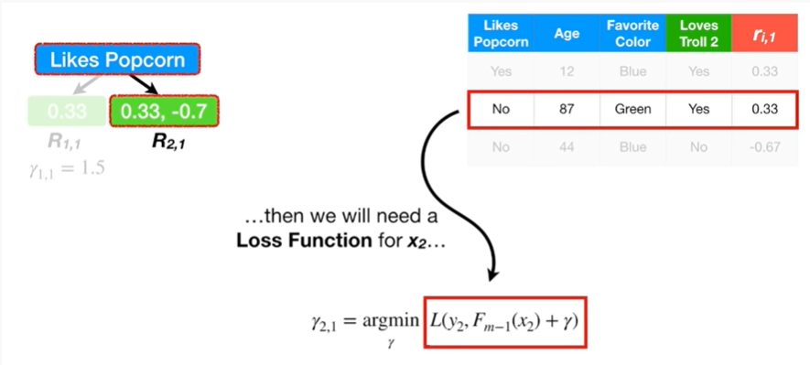

then we will need a loss function for X sub 2

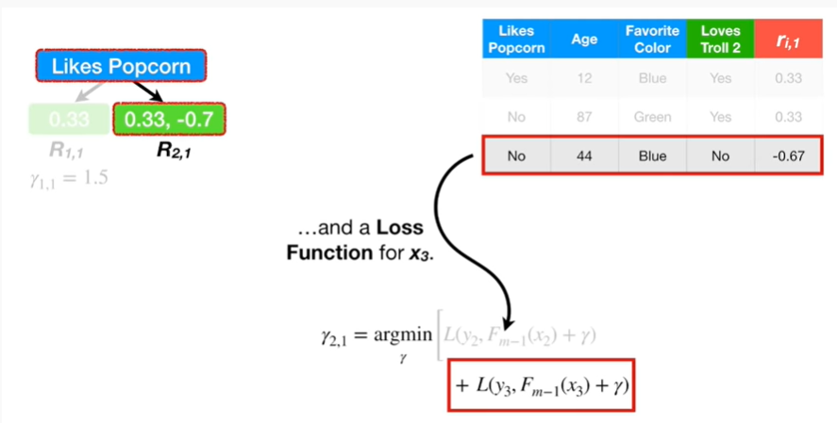

and a loss function for X sub 3.

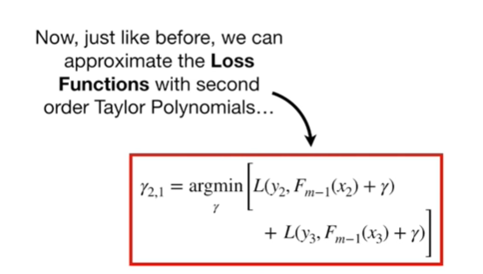

Now, just like before we can approximate the loss function with second-order Taylor polynomials.

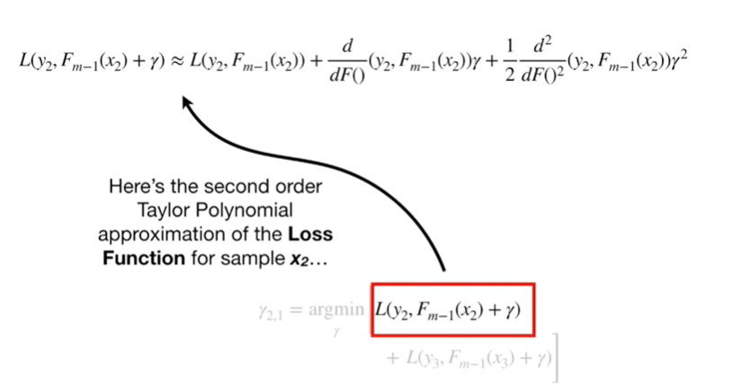

Here's the second-order Taylor polynomial approximation of the loss function for sample X sub 2

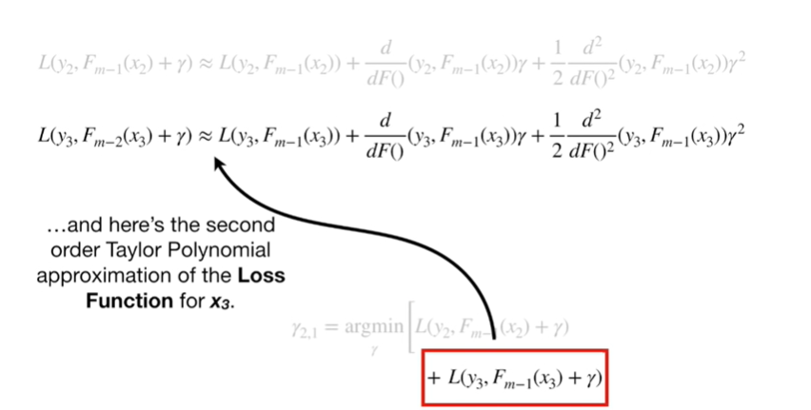

and here's the second-order Taylor polynomial approximation of the loss function for X sub 3.

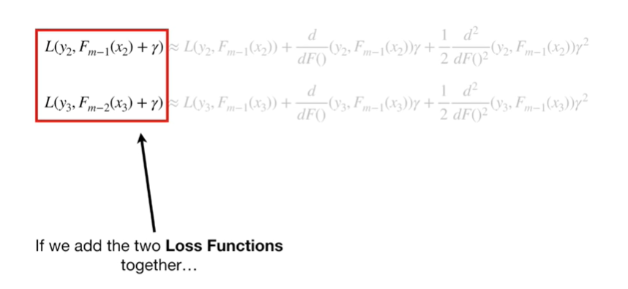

If we add these two loss functions together

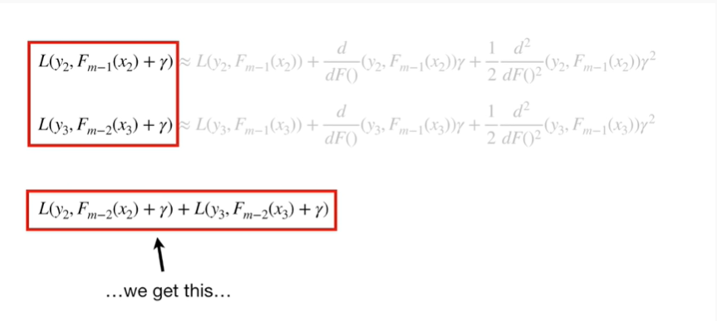

we get this

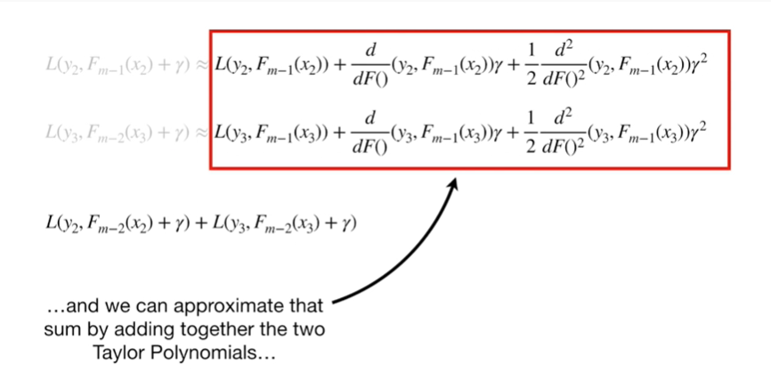

and we can approximate that sum by adding together the two Taylor polynomials.

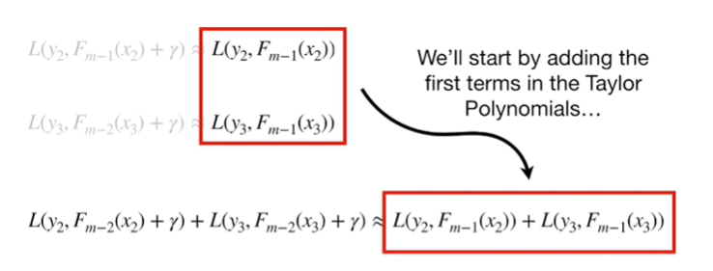

We'll start by adding the first terms into Taylor polynomials

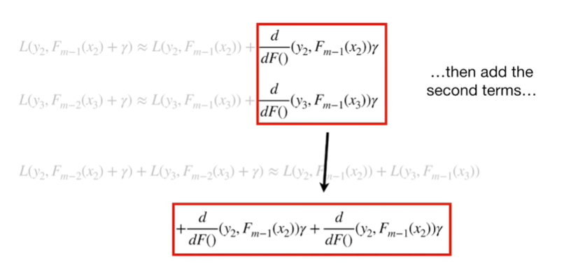

then add the second terms

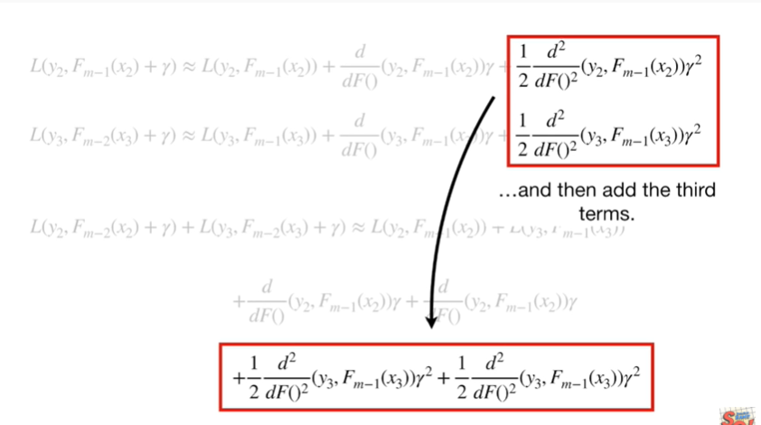

and then add the third terms.

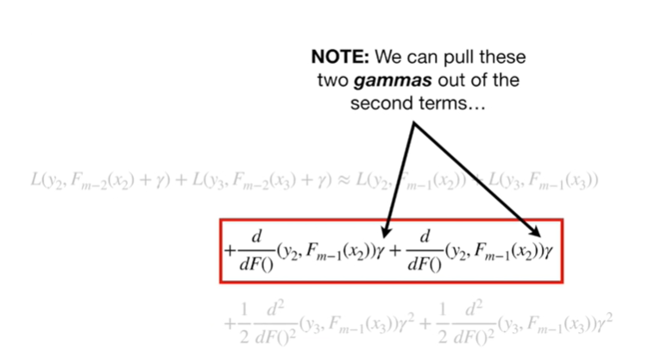

Note : we can pull these two gammas out of the second terms

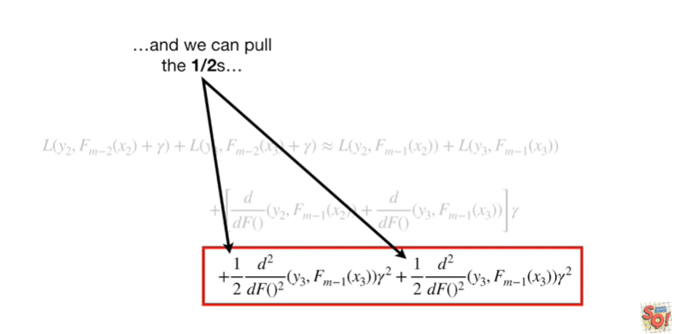

and we can pull the one halfs

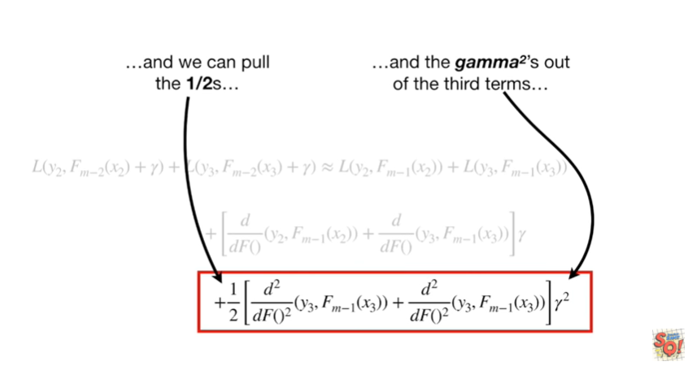

and the game of Squared's out of the third terms.

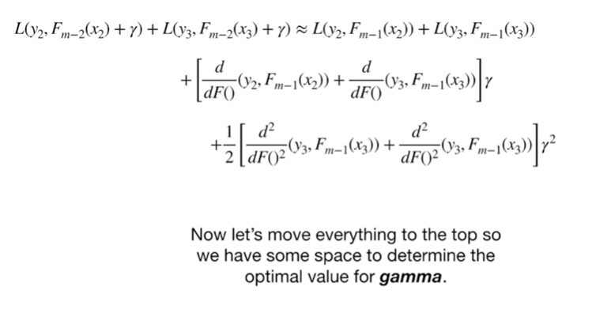

Now let's move everything to the top so we have some space to determine the optimal value for gamma.

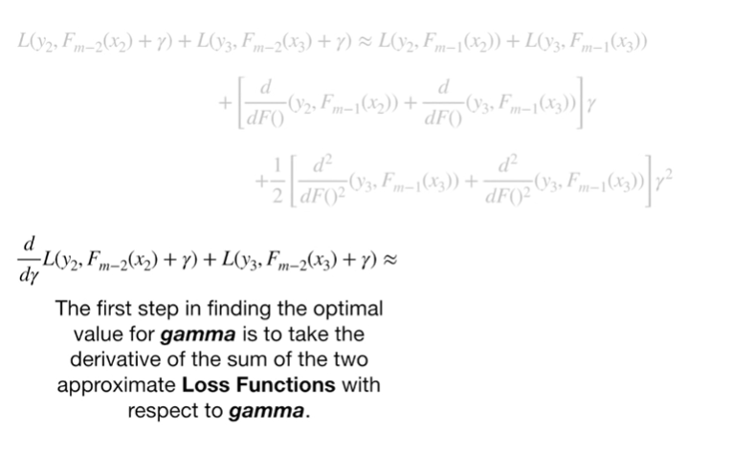

The first step in finding the optimal value for gamma is to take the derivative of the sum of the two approximate loss functions with respect to gamma.

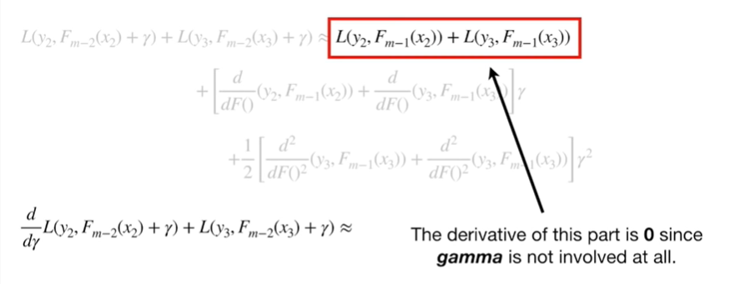

The derivative of this part is zero since gamma is not involved at all.

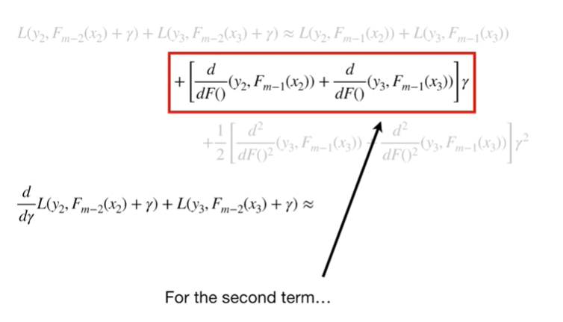

For the second term

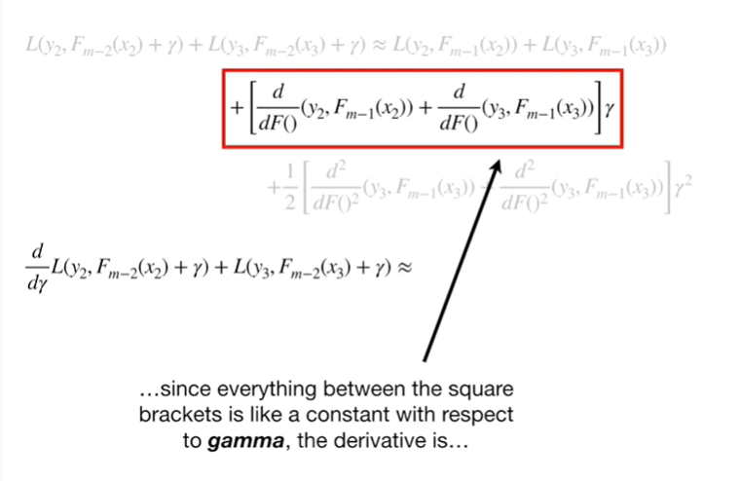

since everything between the square brackets is like a constant with respect to gamma

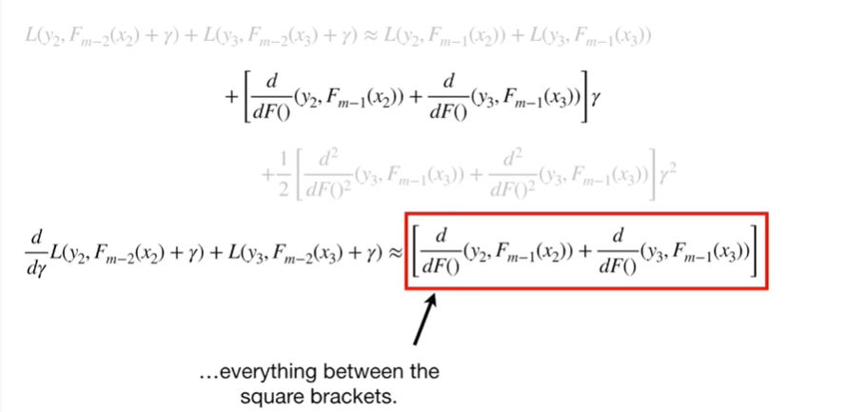

the derivative is everything between the square brackets .

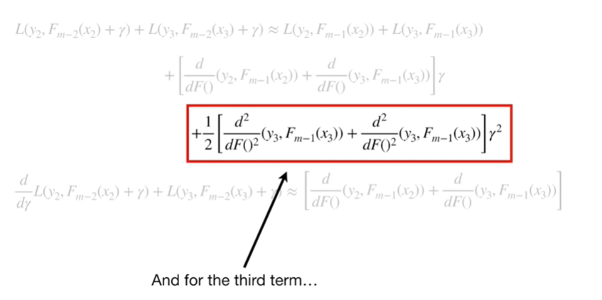

And for the third term the derivative of this with respect to gamma

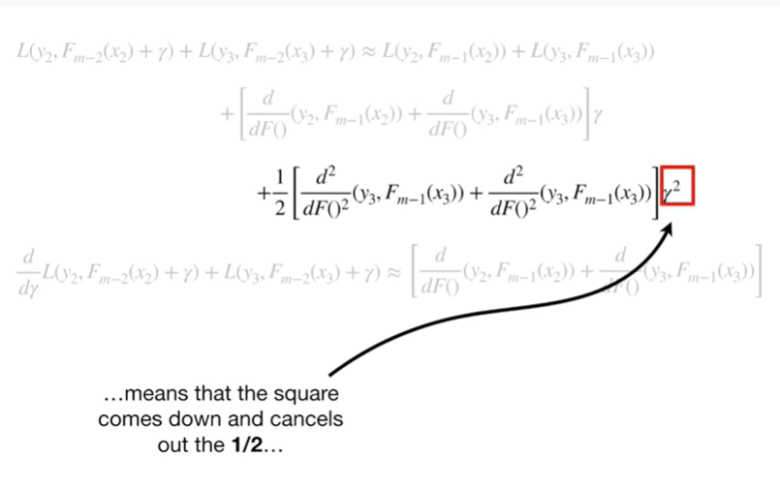

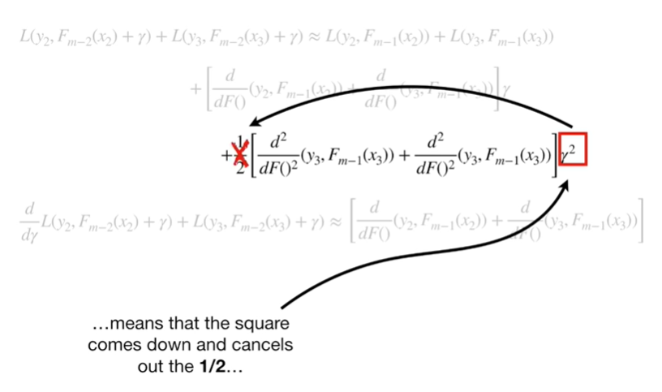

means the square comes down and cancels out the one half

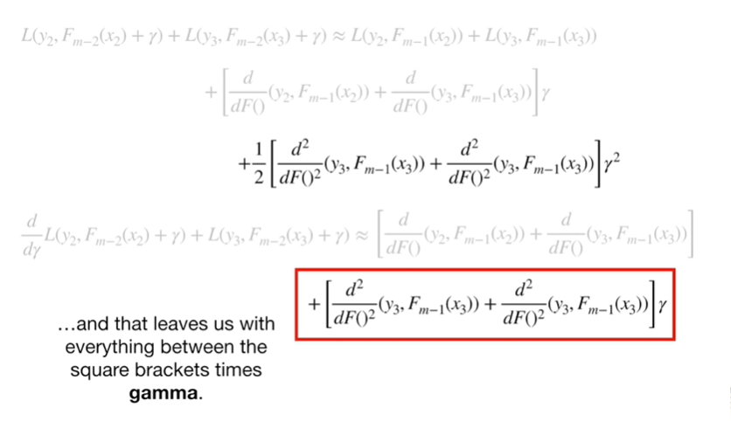

and that leaves us with everything between the square brackets times gamma.

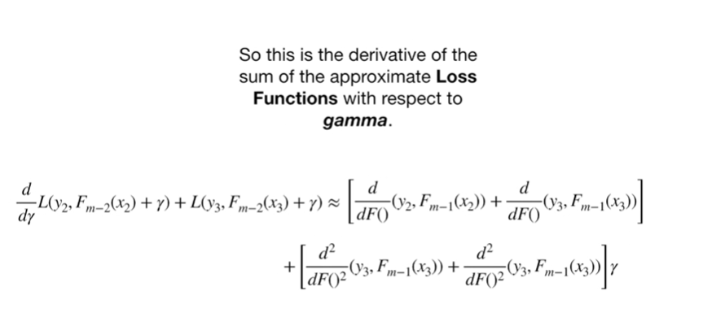

So this is the derivative of the sum of the approximate loss functions with respect to gamma.

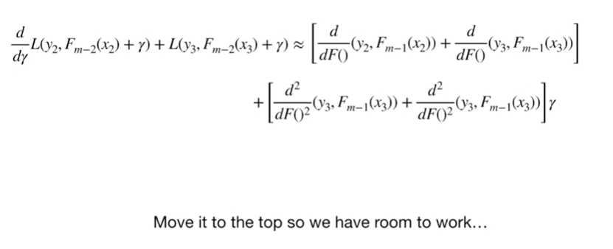

Move it to the top so we have some room to work

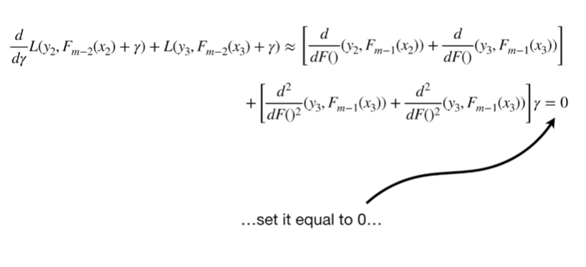

set it equal to zero

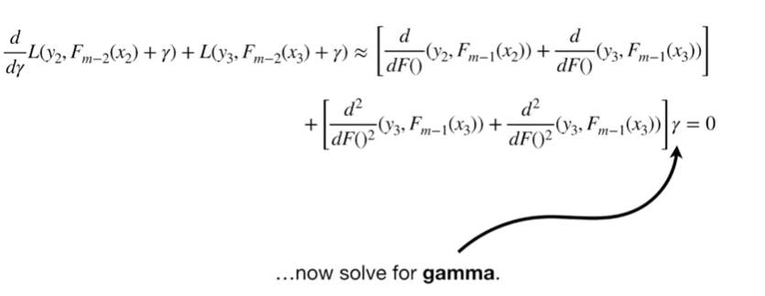

now solve for gamma.

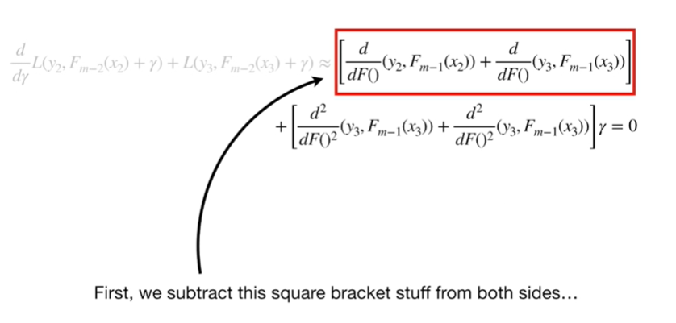

First we subtract this square bracket stuff from both sides

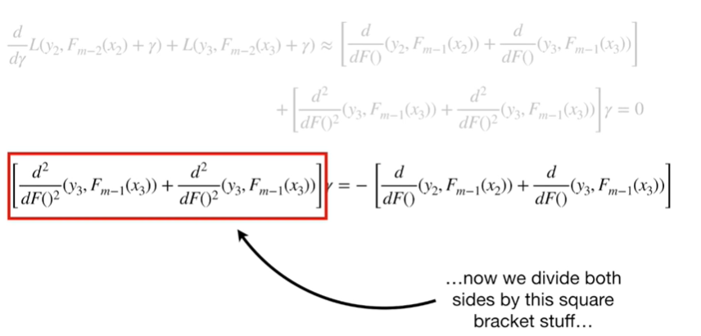

now we divide both sides by this square bracket stuff

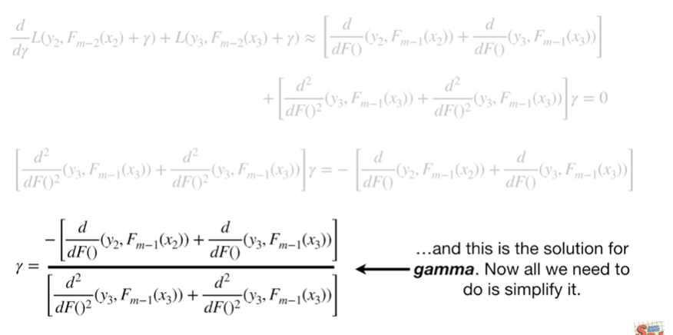

and this is the solution for gamma.

Now all we need to do is simplify it.

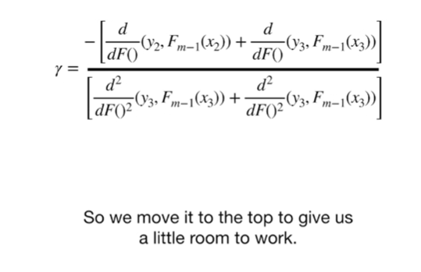

So we move it to the top to give us a little room to work.

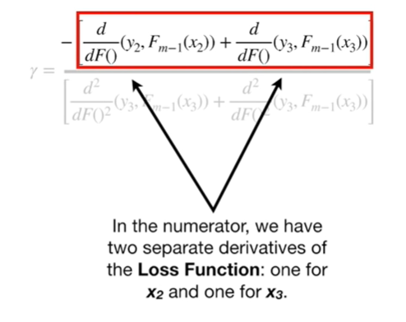

In the numerator we have two separate derivatives of the loss function 1/4 X 2 and 1/4 X 3

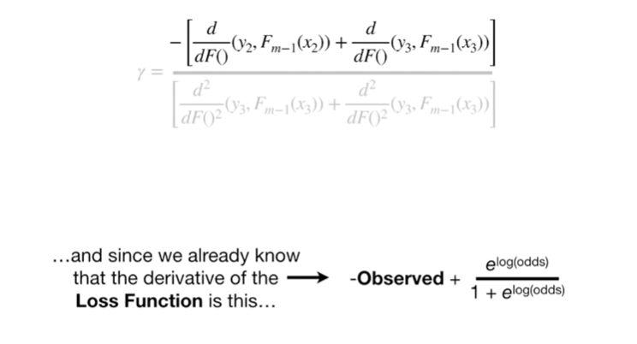

and since we already know that the derivative of the loss function is this

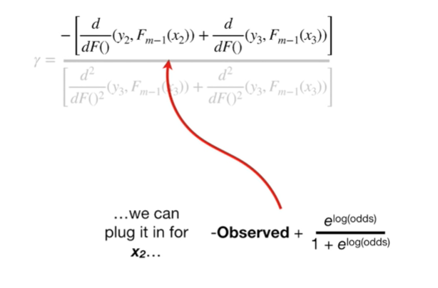

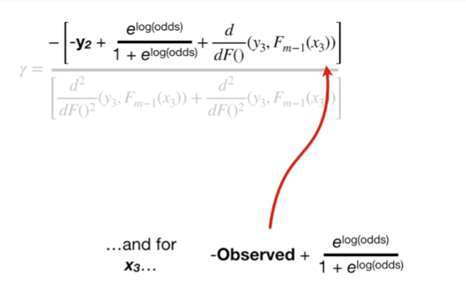

we can plug it in for X 2 + 4 X 3

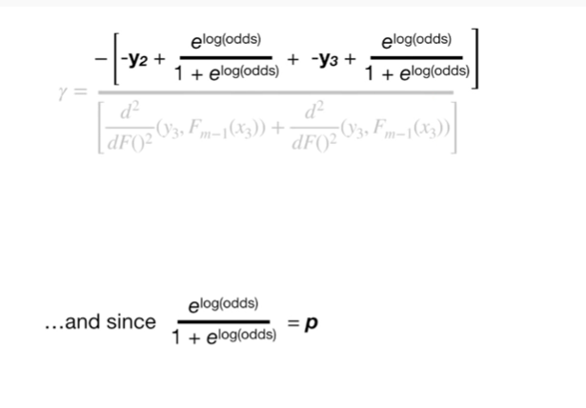

and since e to the log odds divided by one plus e to the log odds equals P

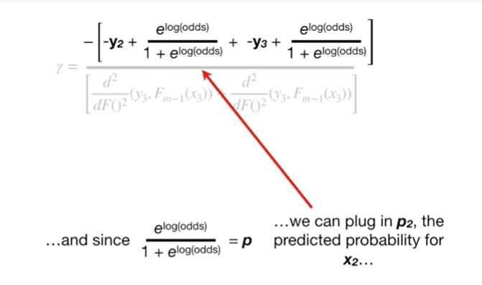

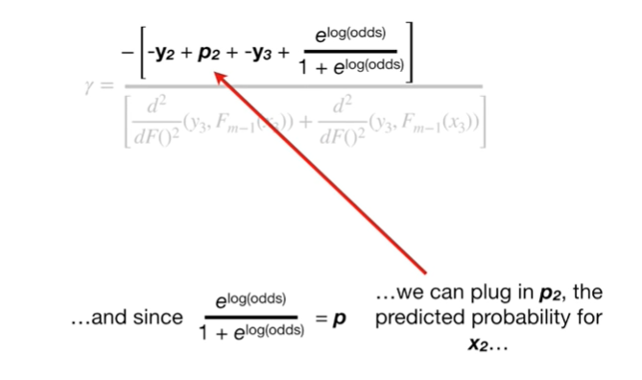

we can plug in P sub to the predicted probability for X sub 2

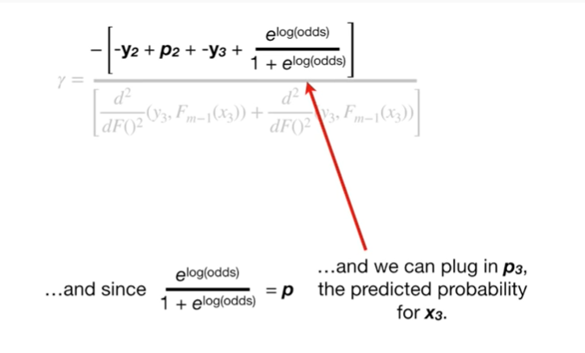

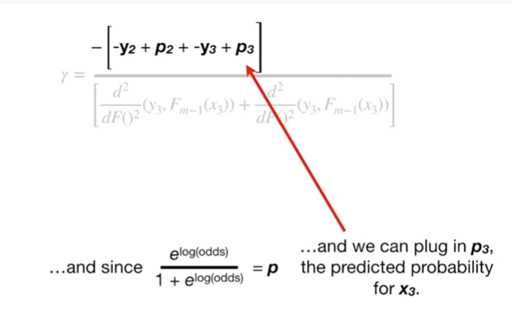

and we can plug in P sub 3 the predicted probability for X sub 3.

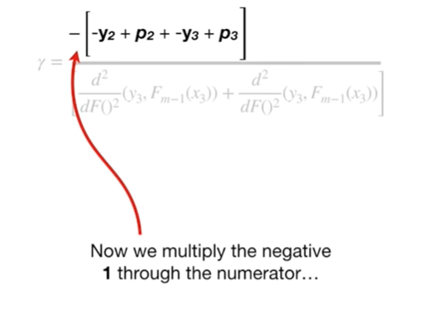

Now we multiply the negative 1 through the numerator

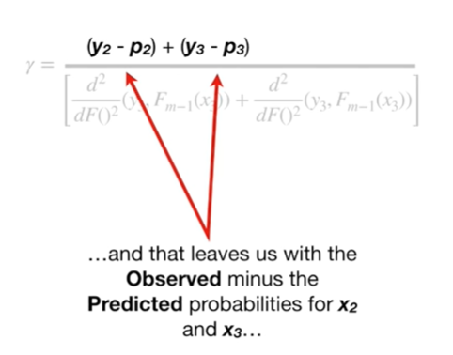

and that leaves us with the observed minus the predicted probabilities for X sub 2 and X sub 3.

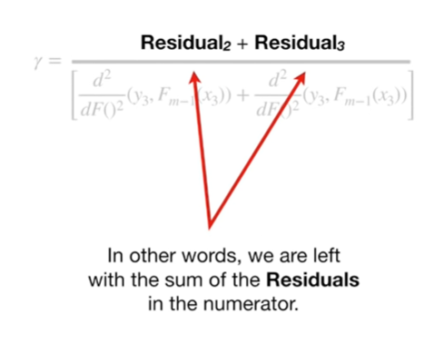

In other words, we are left with the sum of the residuals in the numerator.

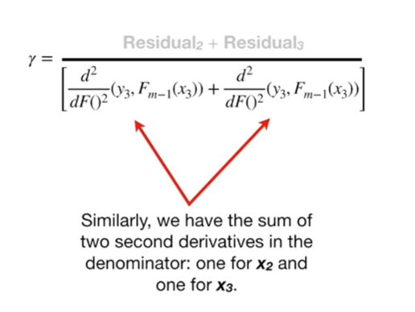

Similarly we have the sum of two second derivatives in the denominator 1 for X sub 2 and 1 for X sub 3.

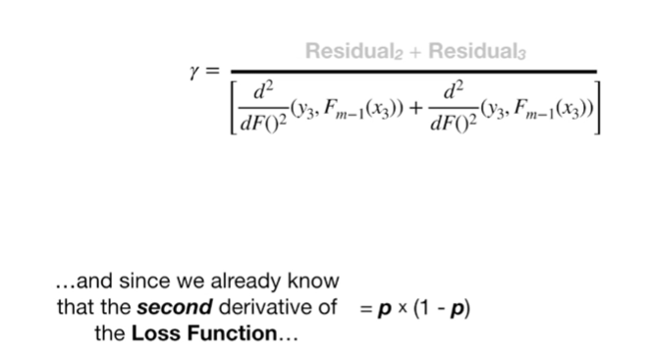

And since we already know that the second derivative of the loss function equals P times 1 minus P

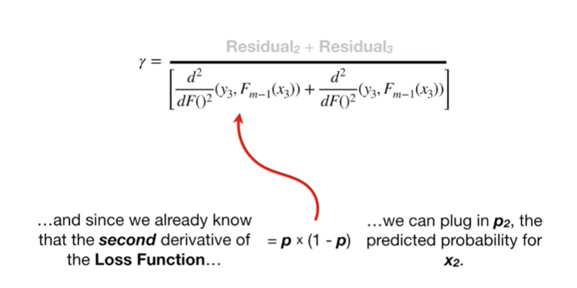

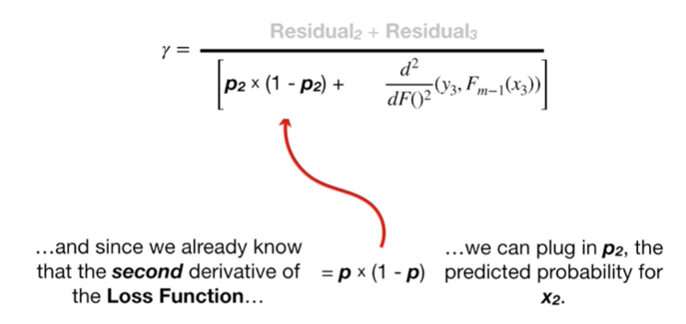

we can plug in P sub 2 for the predicted probability for X sub 2

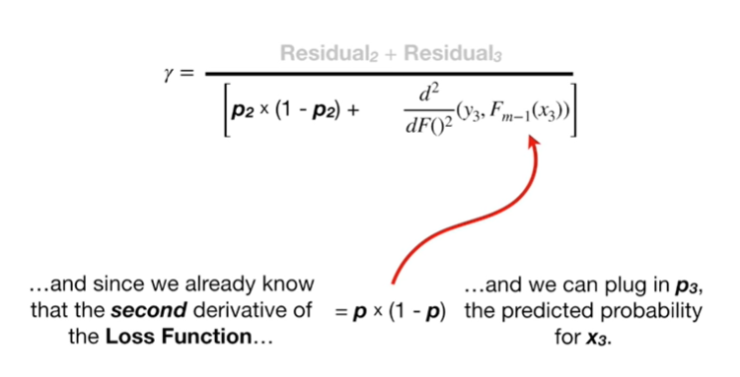

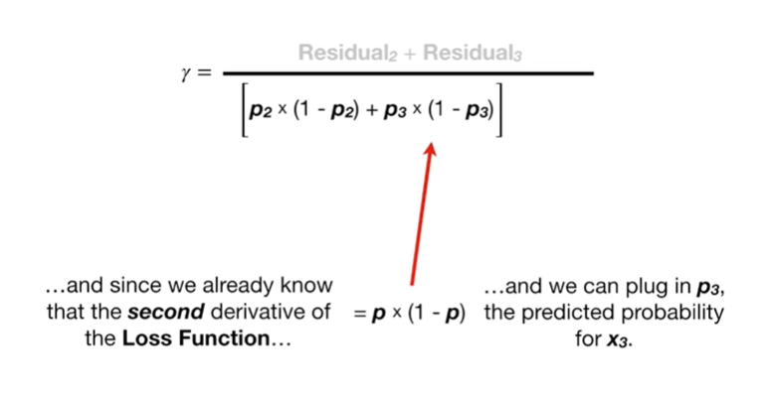

and we can plug in P sub 3 the predicted probability for X sub 3.

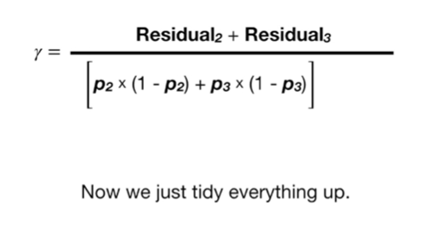

Now we just tidy everything up.

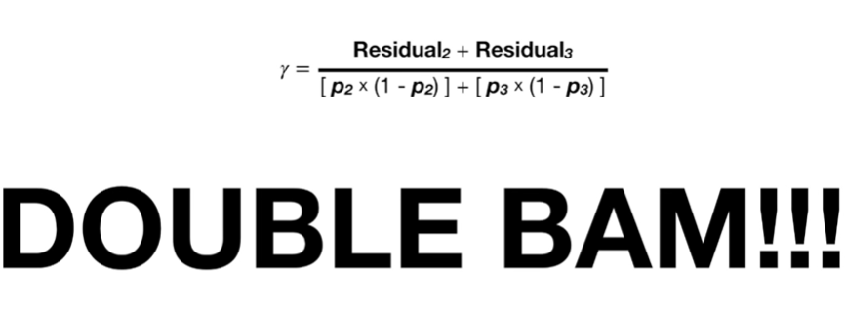

Double BAM !!!

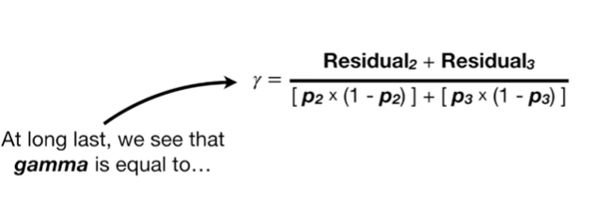

At long last, we see that gamma is equal to

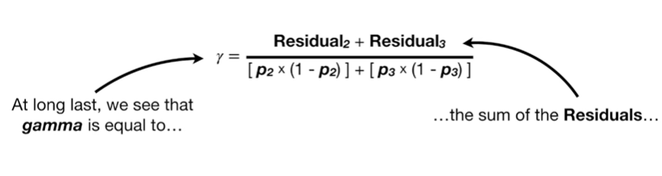

the sum of the residuals

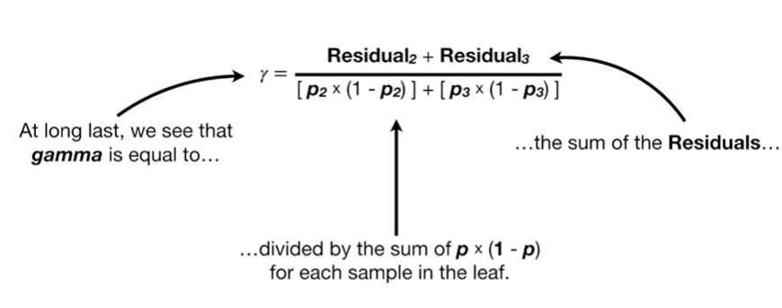

divided by the sum of P times 1 minus P for each sample in the leaf.

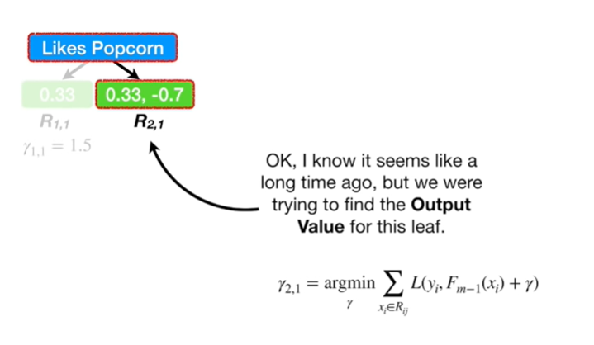

Okay, I know it seems like a long time ago but we were trying to find the output value for this leaf.

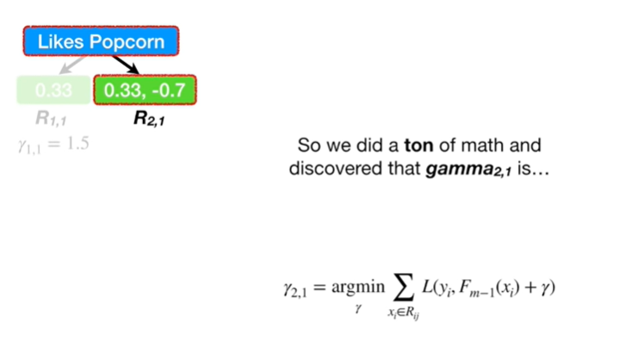

So we did a ton of math and discovered that gamma sub 2 comma 1 is

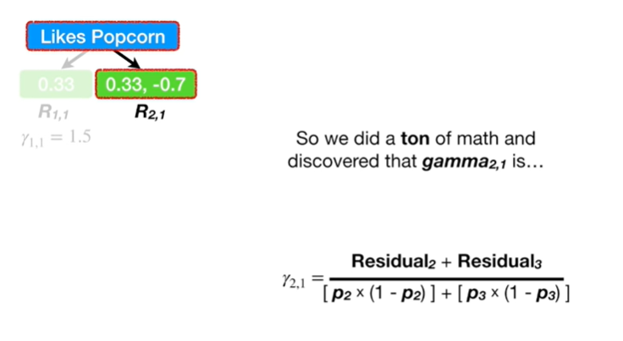

the sum of the residuals divided by the sum of P times 1 minus P for each sample that ended up in the leaf.

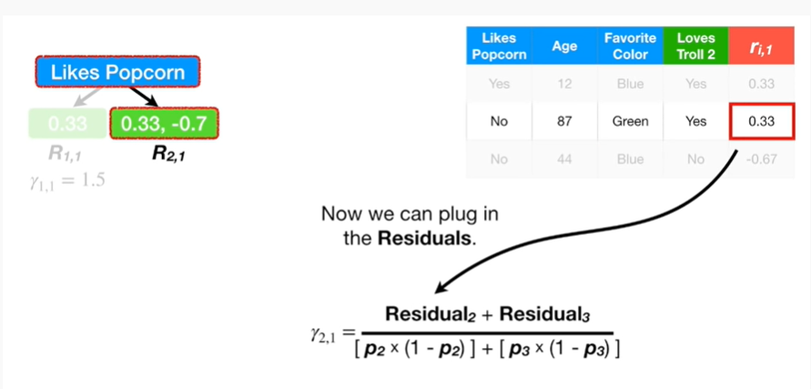

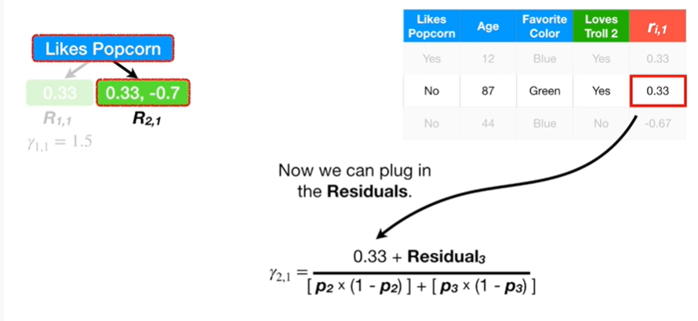

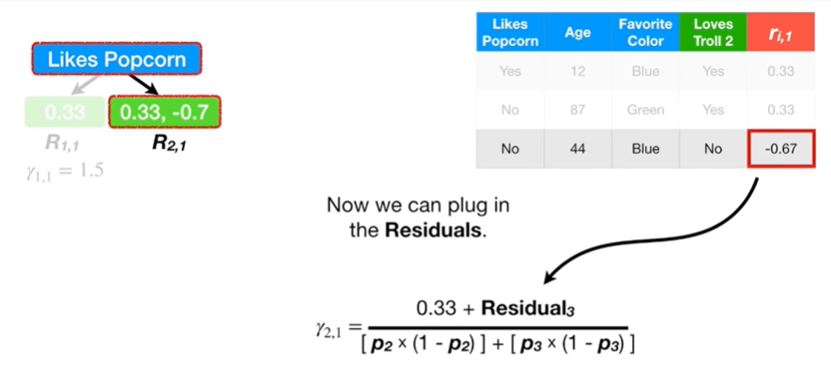

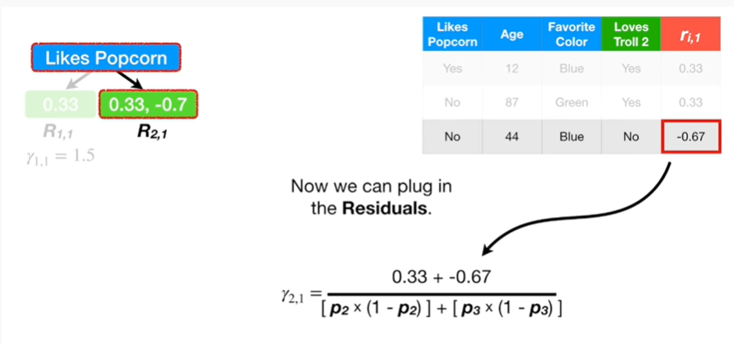

Now we can plug in the residuals

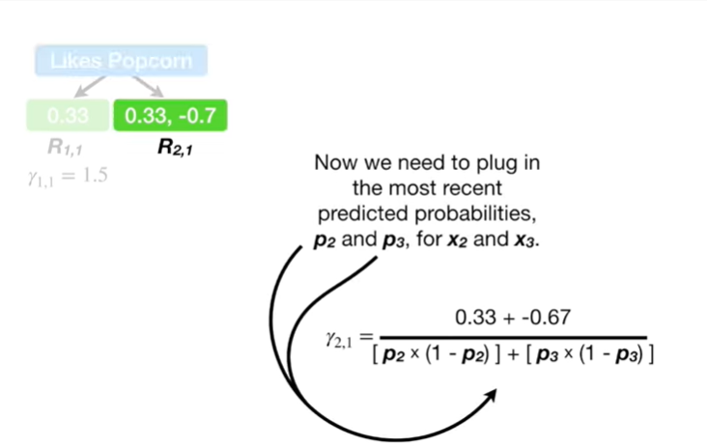

now we need to plug in the most recent predicted probabilities P 2 and P 3 for X 2 and X 3.

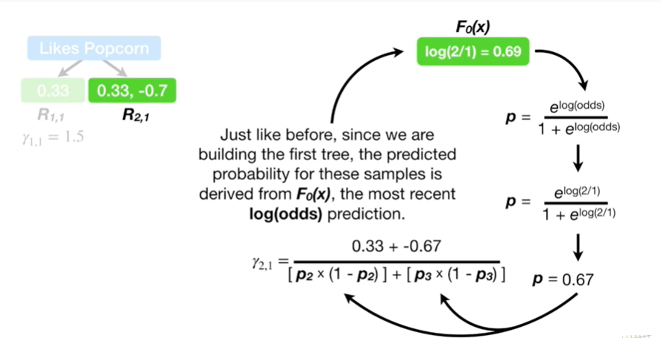

Just like before since we are building the first tree the predicted probability for these samples is derived from F sub 0 of X the most recent log-odds prediction.

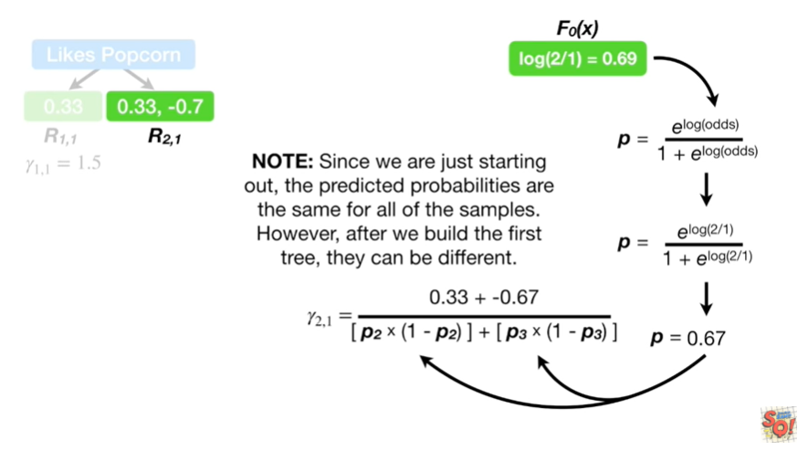

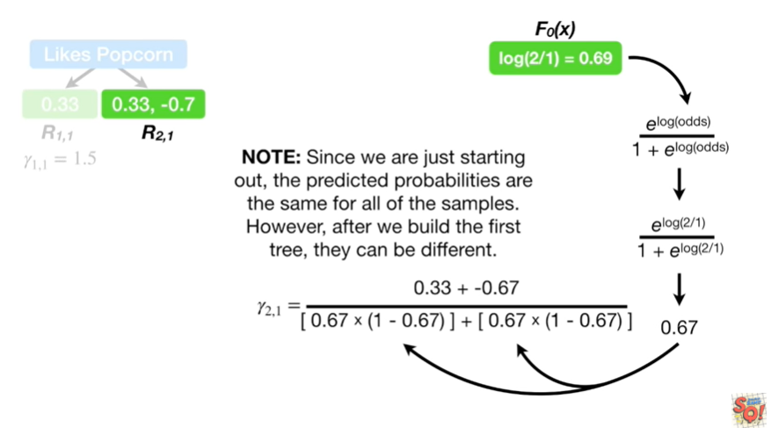

Note : since we are just starting out the predicted probabilities are the same for all of the samples however after we build the first tree, they can be different.

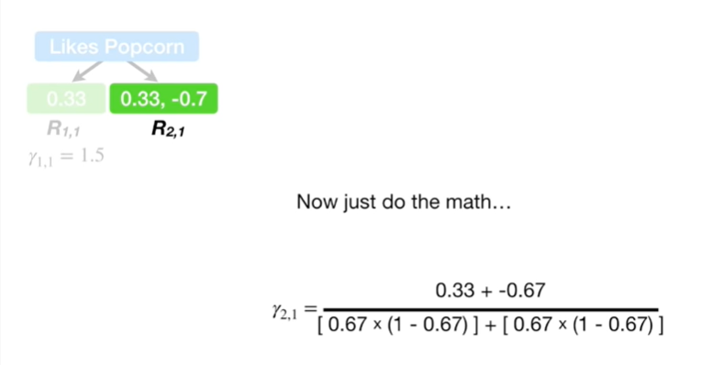

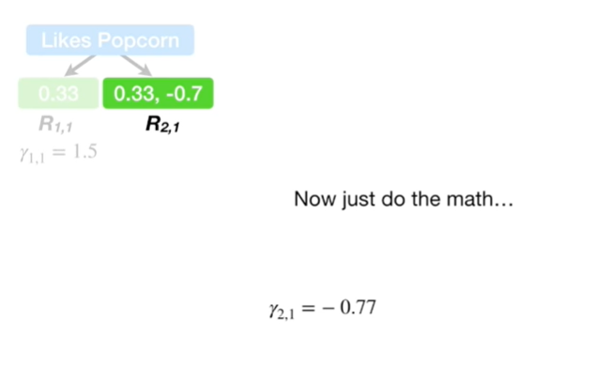

Now just do the math

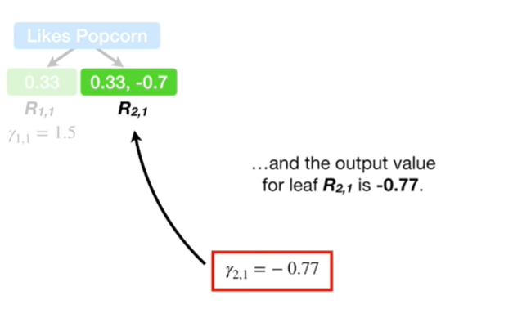

and the output value for leaf R sub 2 comma 1 is negative 0.77.

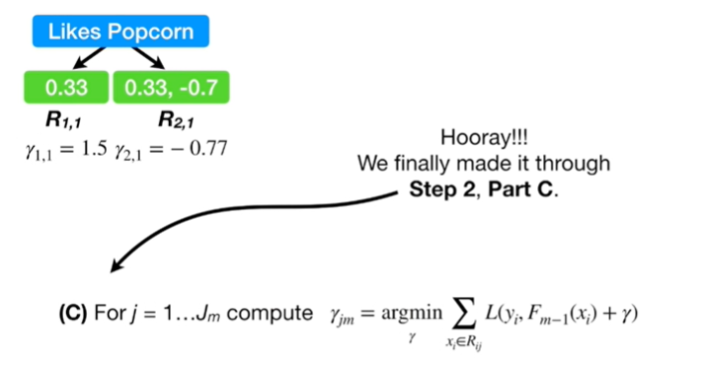

Hooray !

We made it through step 2 Part C.

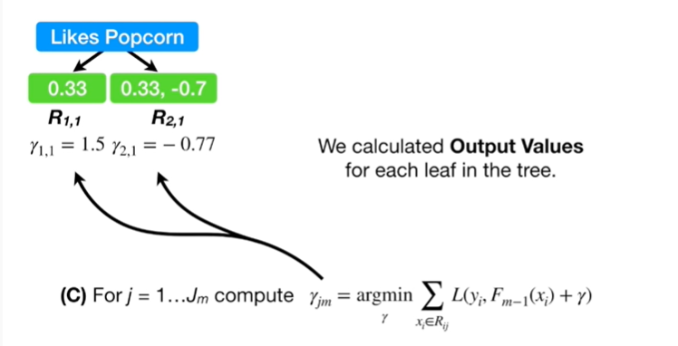

We calculated output values for each leaf in the tree.

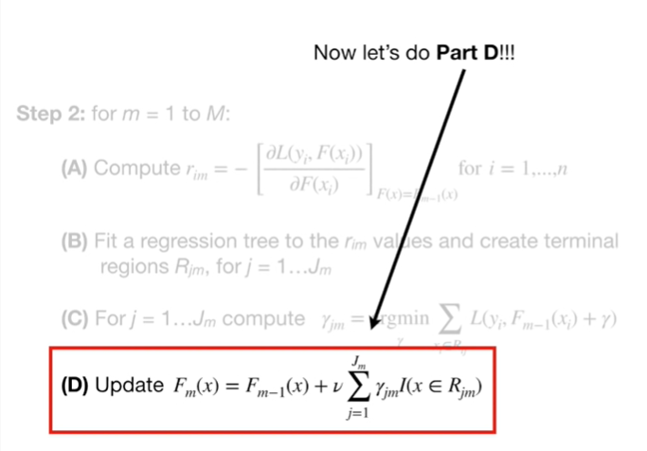

Now let's do Part D.

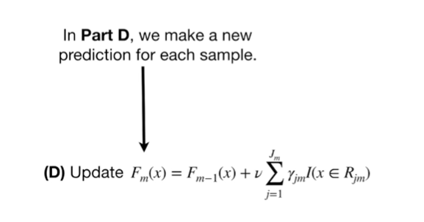

In Part D we make a new prediction for each sample.

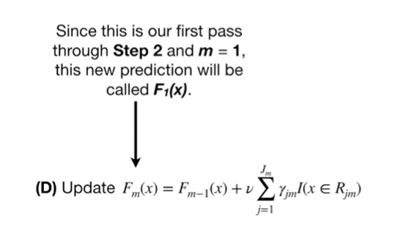

Since this is our first pass through step 2 and M equals 1, this new prediction will be called F sub 1 of X.

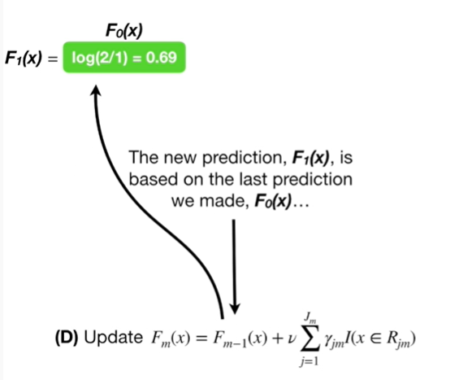

The new prediction, F sub 1 of X, is based on the last prediction we made, F sub 0 of X

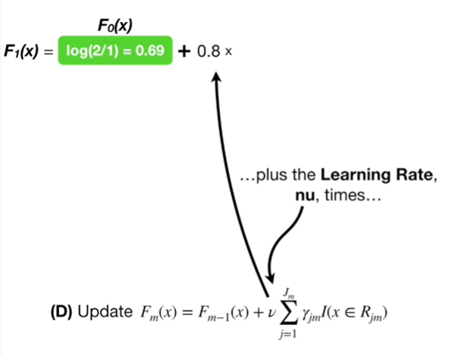

plus the learning rate new times

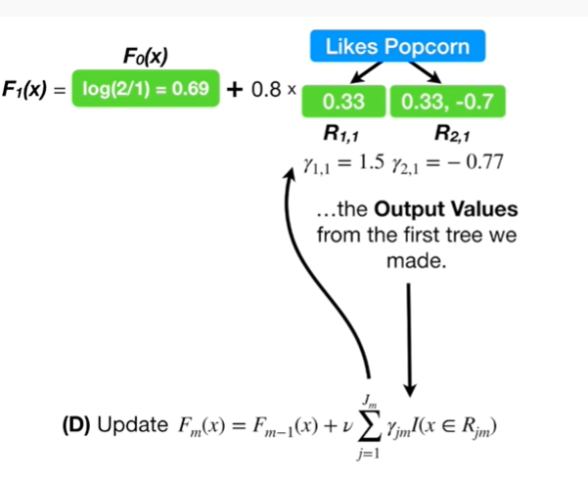

the output values from the first tree we made.

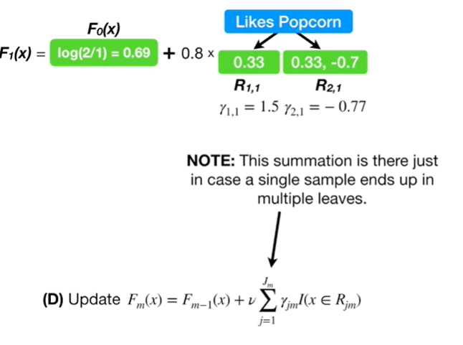

Note : this summation is there just in case a single sample ends up in multiple leaves.

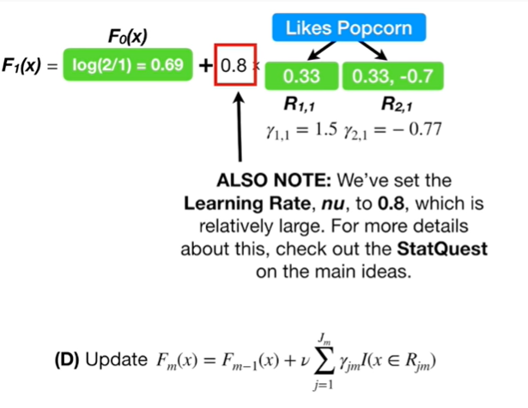

Also note : we've set the learning rate, nu, to 0.8, which is relatively large.

For more details about this check out the stat quest on the main ideas.

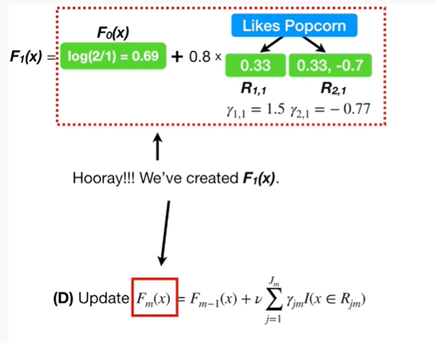

Hooray !

We've created F sub 1 of X now we will use F sub 1 of X.

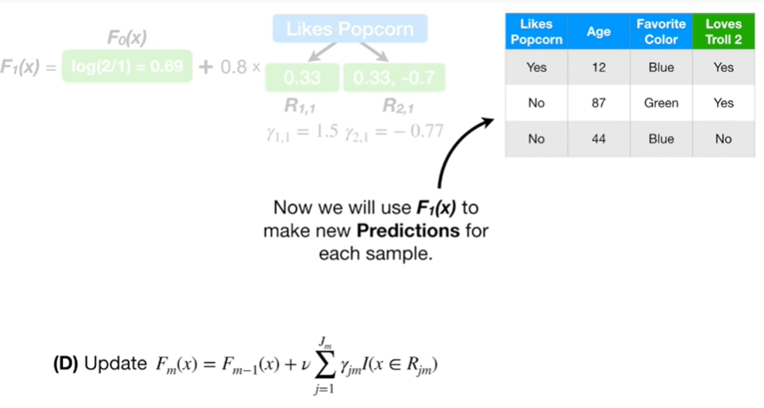

To make new predictions for each sample.

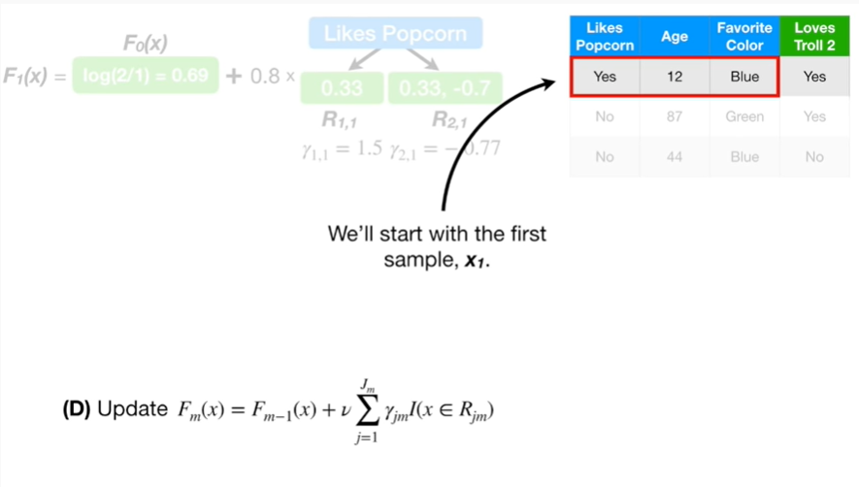

We'll start with the first sample x sub 1.

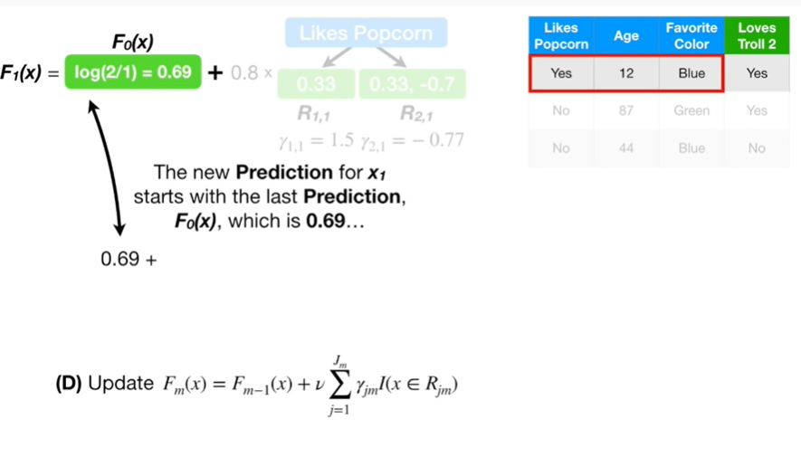

The new prediction for X sub 1 starts with the last prediction, F sub 0 of X, which is 0.6 9

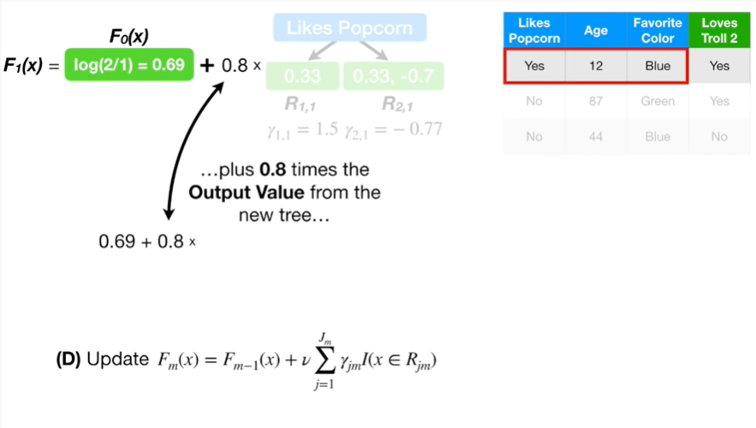

plus 0.8 times the output value from the new tree

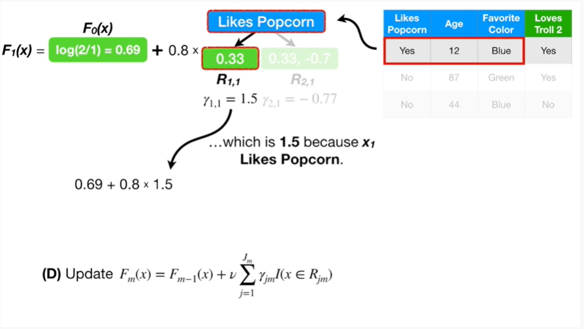

which is 1.5 because X sub 1 likes popcorn.

By the way, I love popcorn too.

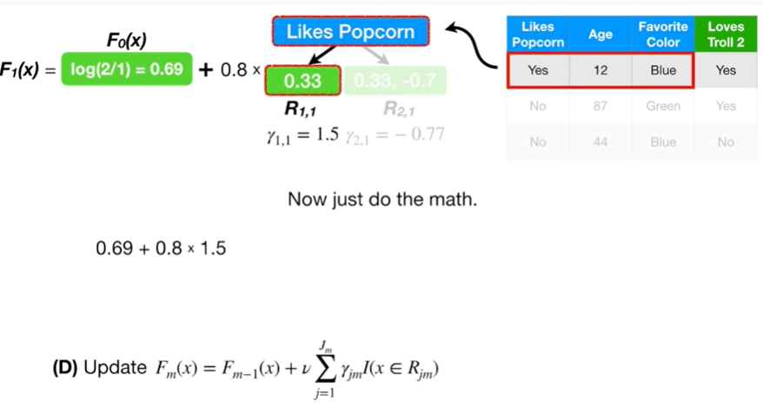

Now just do the math.

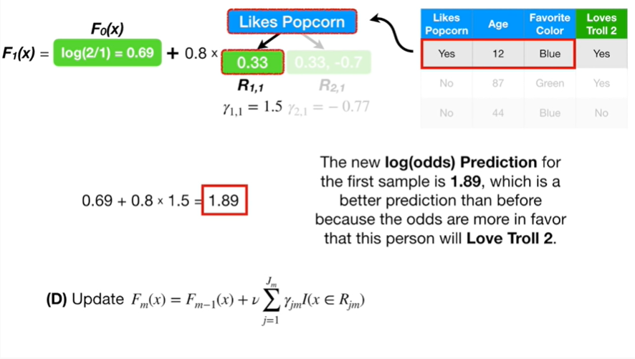

The new log-odds prediction for the first sample is 1 point 8 9, which is a better prediction than before because the odds are more in favor that this person will love troll 2.

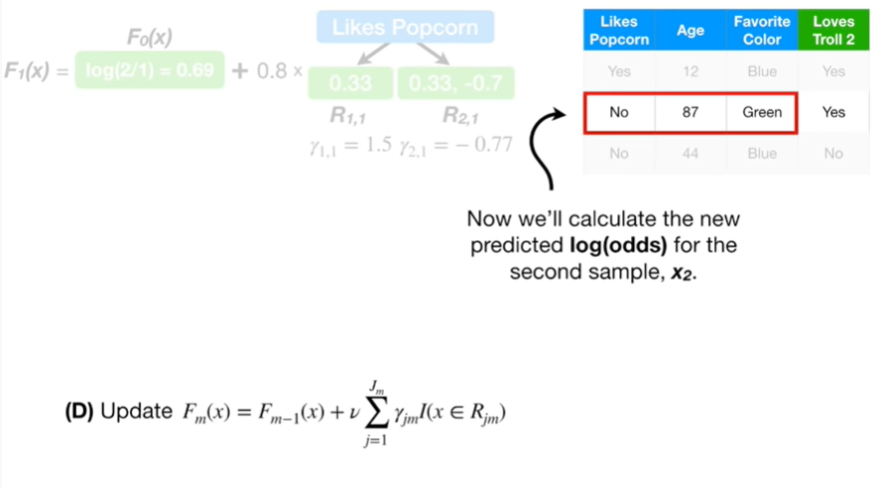

Now we'll calculate the new predicted log odds for the second sample, X sub 2.

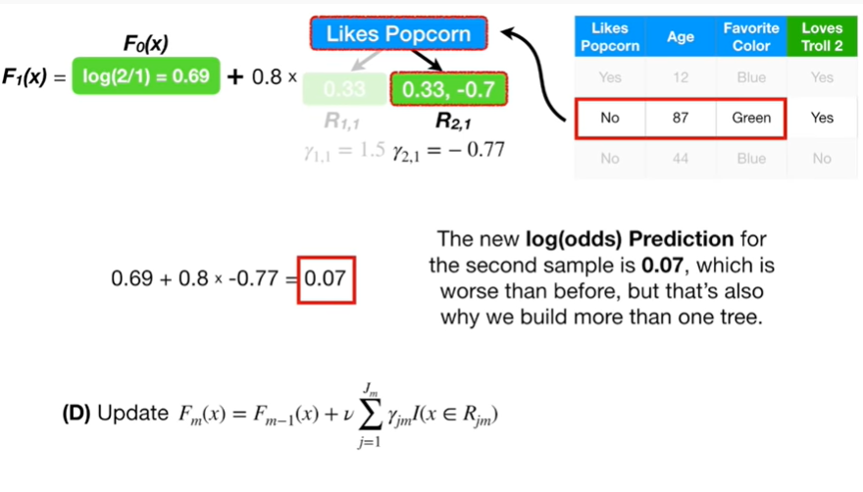

The new log odds prediction for the second sample is 0.07, which is worse than before, but that's also why we build more than one tree.

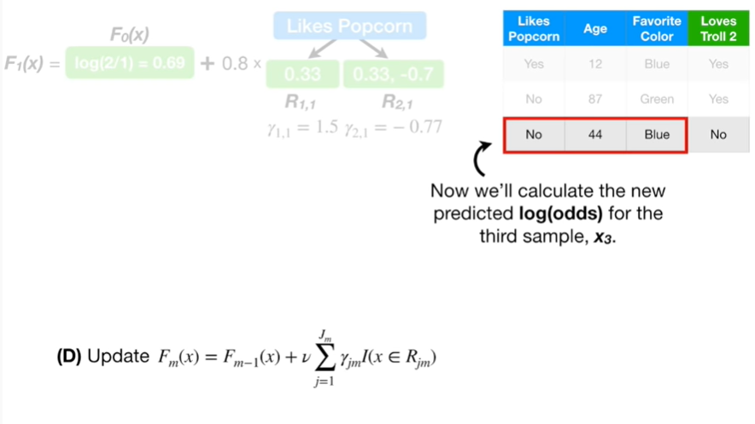

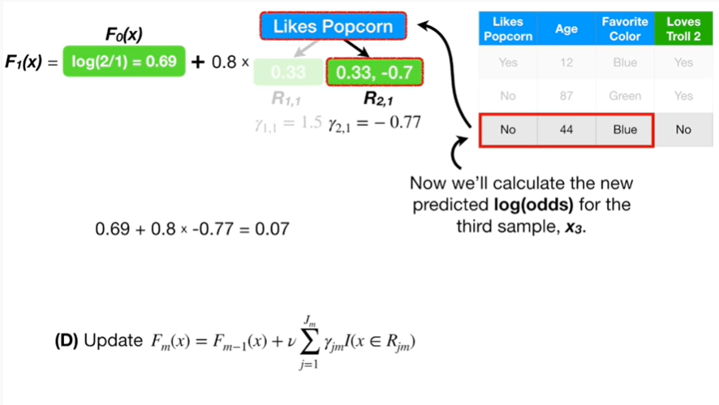

Now we'll calculate the new predicted log odds for the third sample X sub 3.

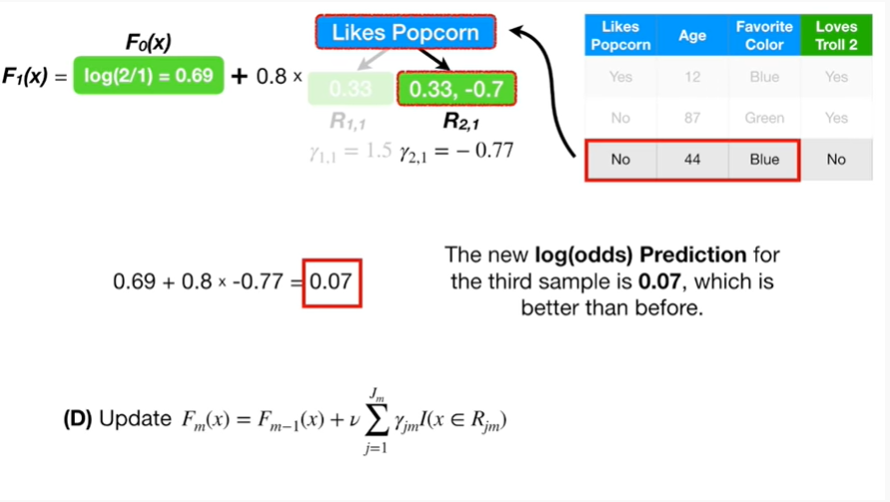

The new log odds prediction for the third sample is 0.07, which is better than before.

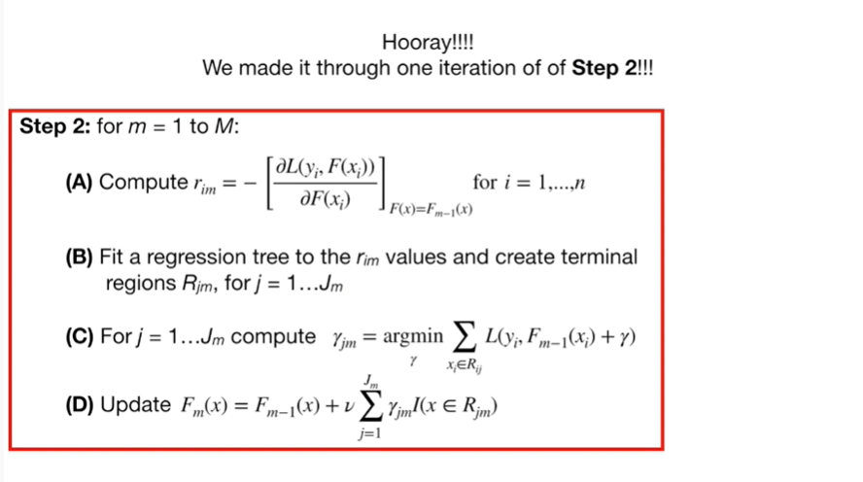

Hooray !

We made it through one iteration of step 2.

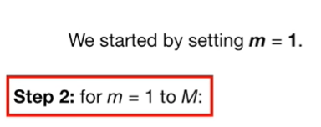

We started by setting little m equal to one.

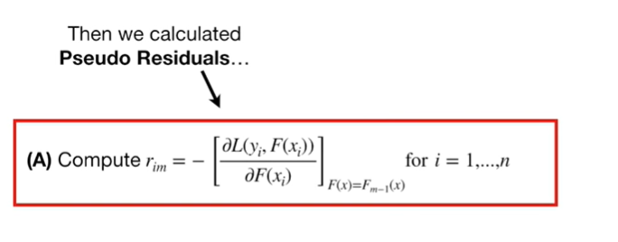

Then we calculated pseudo residuals

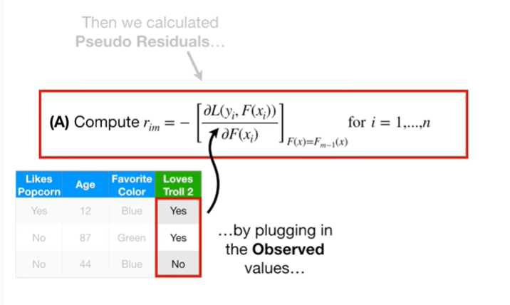

by plugging in the observed values

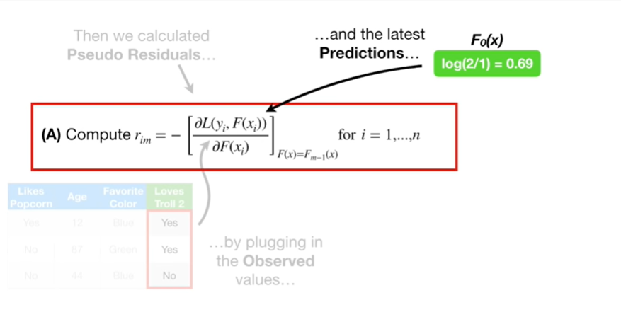

and the latest predictions

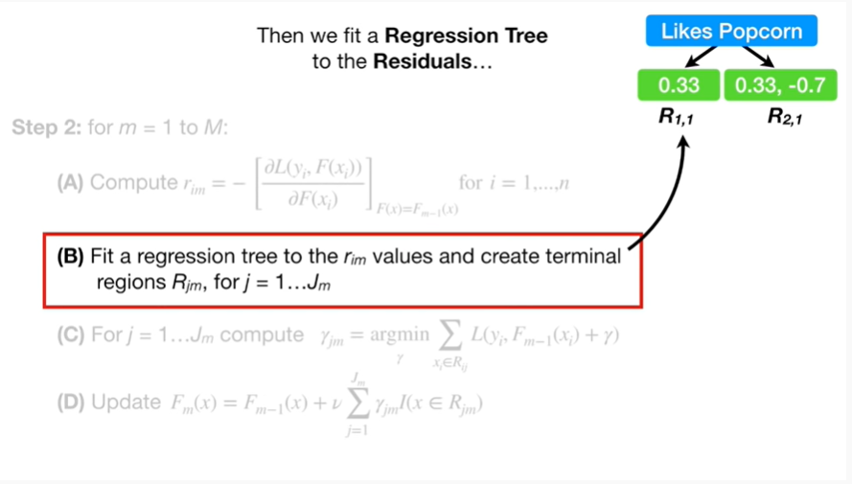

and that gave us residuals then we fit a regression tree to the residuals

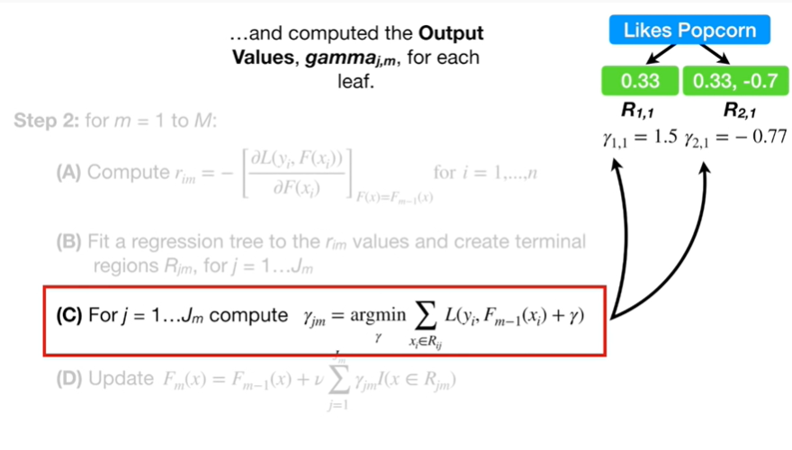

and computed the output values gamma sub J comma M for each leaf.

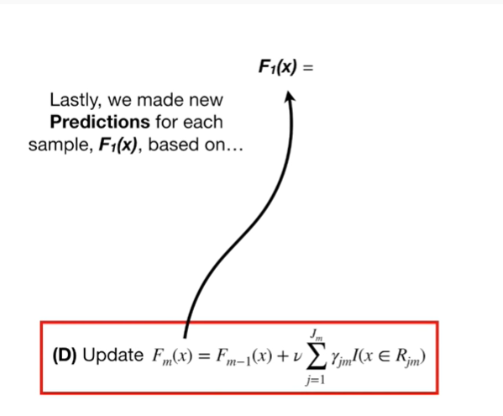

Lastly, we've made new predictions for each sample F sub 1 of X based on

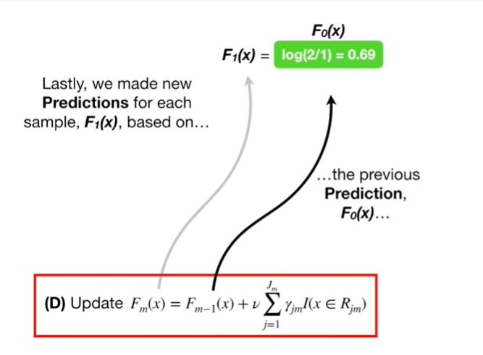

the previous prediction F sub 0 of X

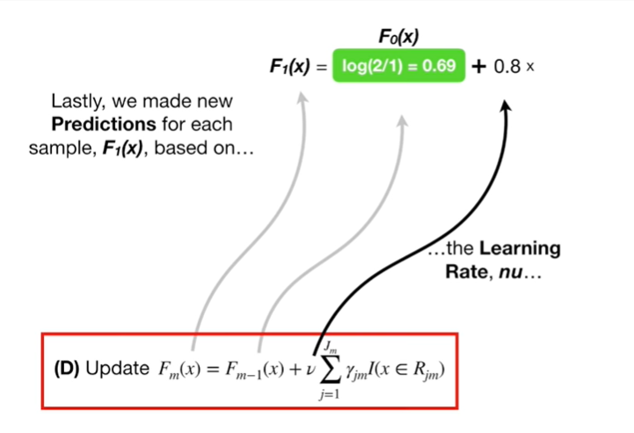

the learning rate nu

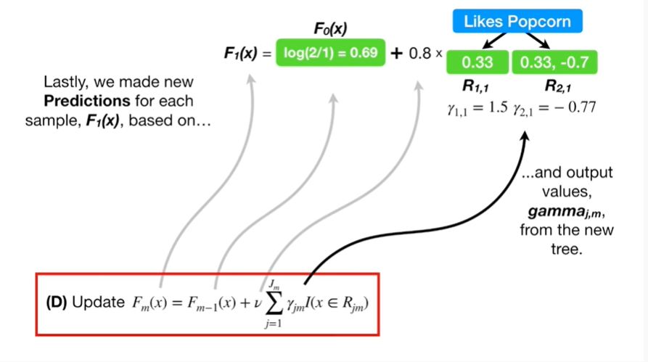

and the output values gamma sub J comma M from the new tree.

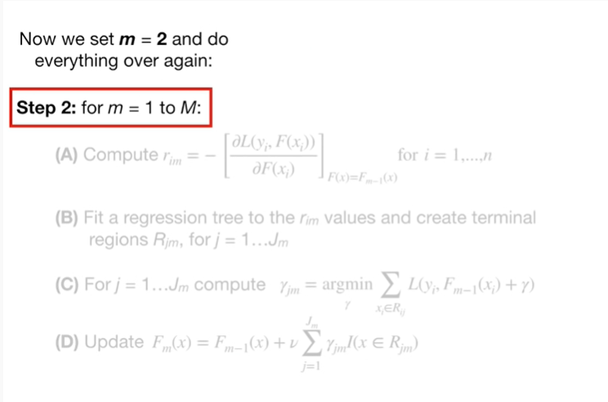

Now we set little m equal to 2 and do everything over again :

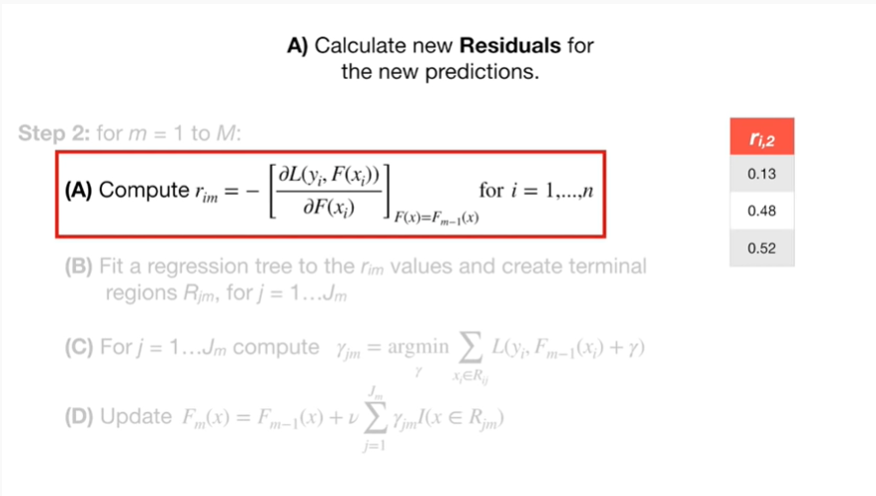

A. calculate new residuals for the new predictions.

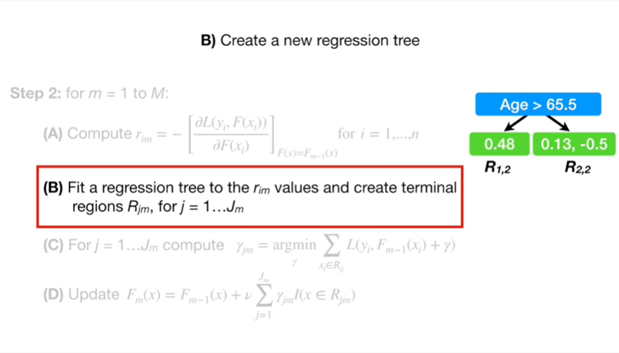

B. create a new regression tree.

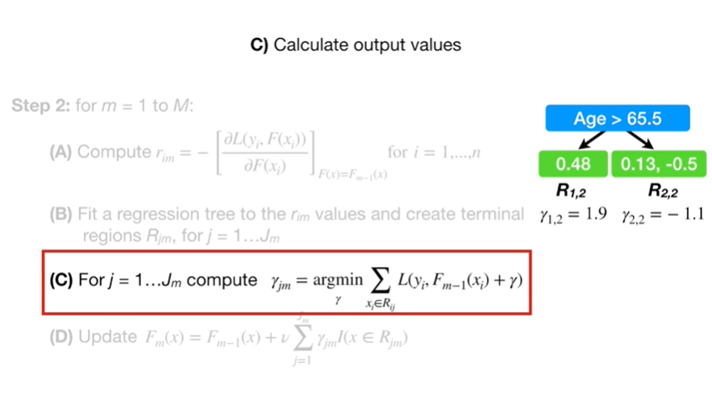

C. calculate output values

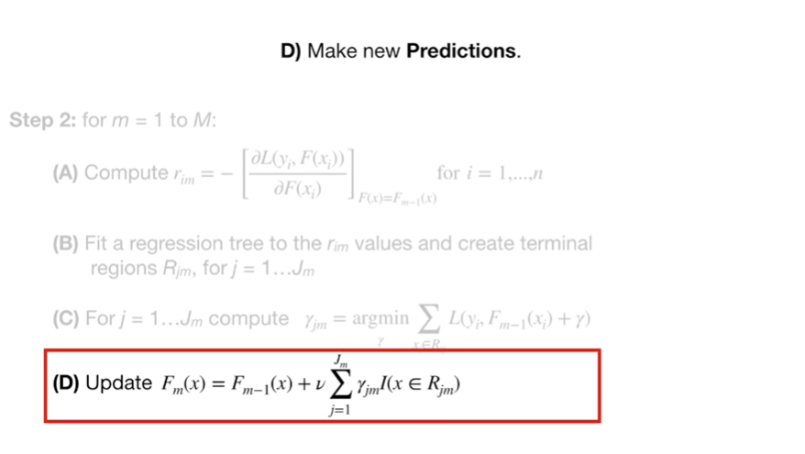

And D. make new predictions.

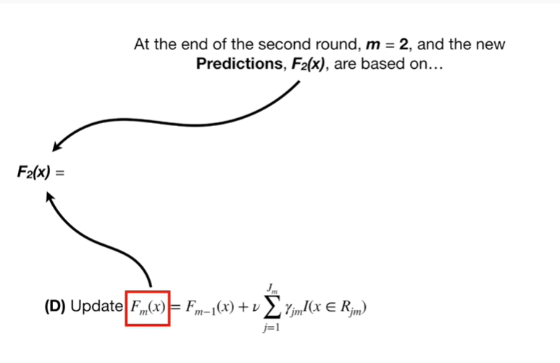

At the end of the second round little M equals two and the new predictions F sub two of X are based on

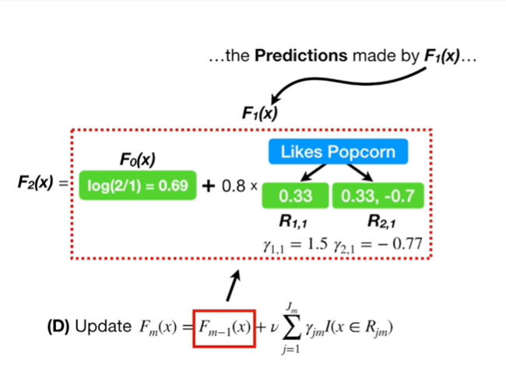

the predictions made by F sub 1 of X

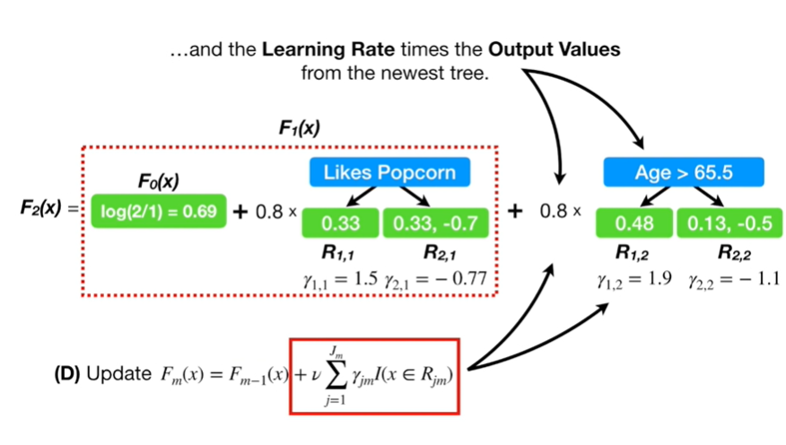

and the learning rate times the output values from the newest tree.

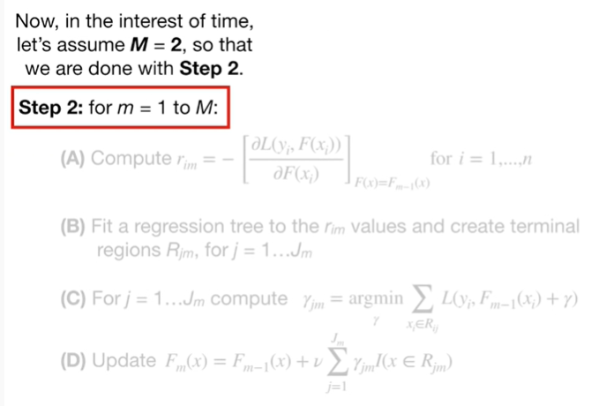

Now in the interest of time let's assume Big M equals two.

So that we are done with step two.

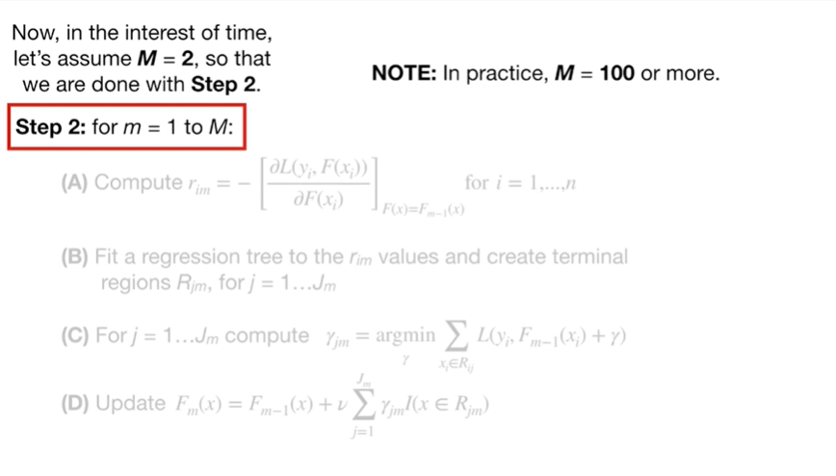

Note : in practice m equals 100 or more.

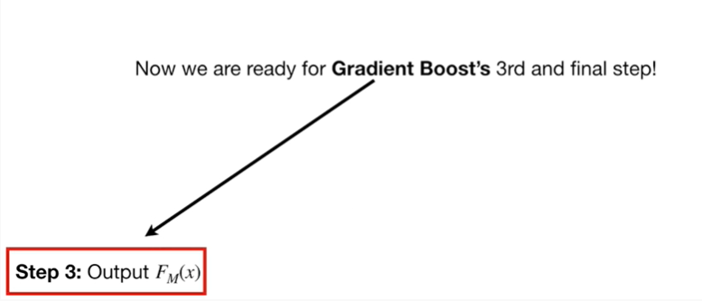

Now we are ready for gradient boosts 3 and final step.

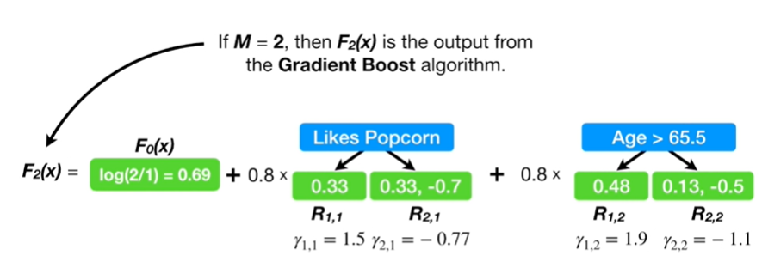

If Big M equals 2 then F sub 2 of X is the output from the gradient boost algorithm.

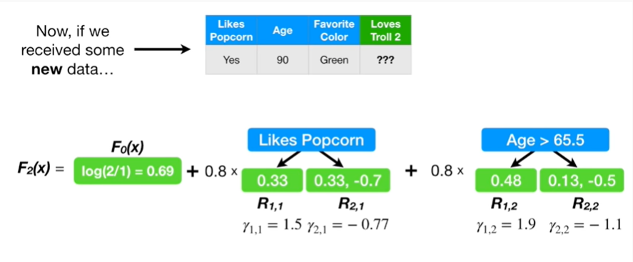

Now if we receive some new data we would use

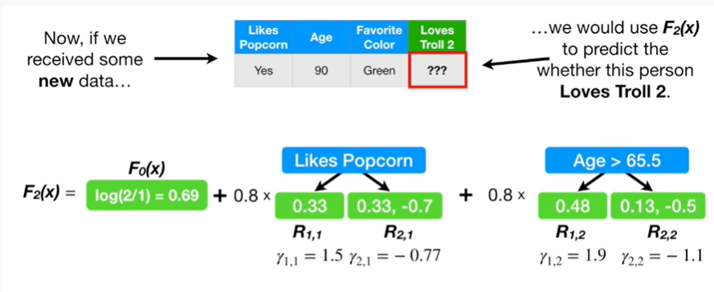

F sub 2 of X to predict whether this person loves troll 2.

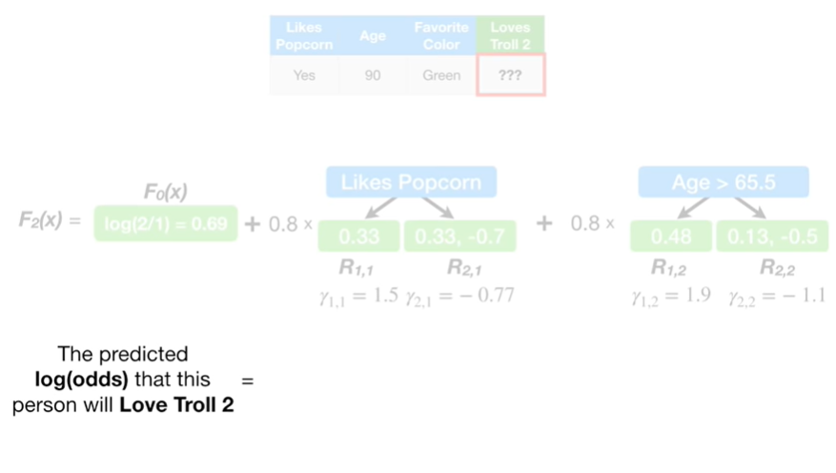

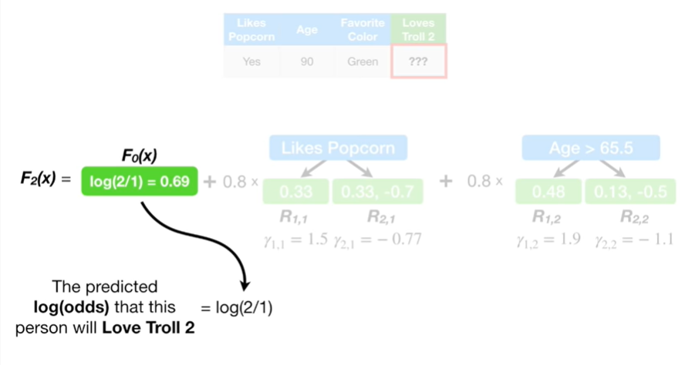

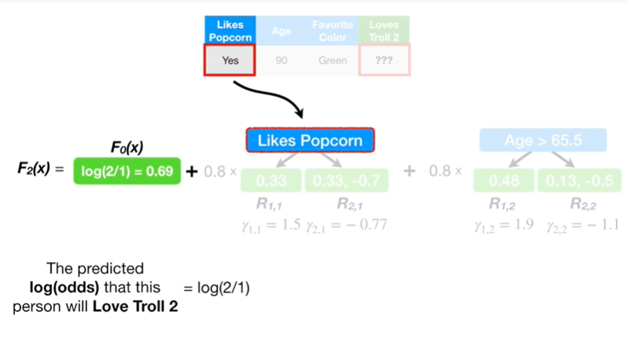

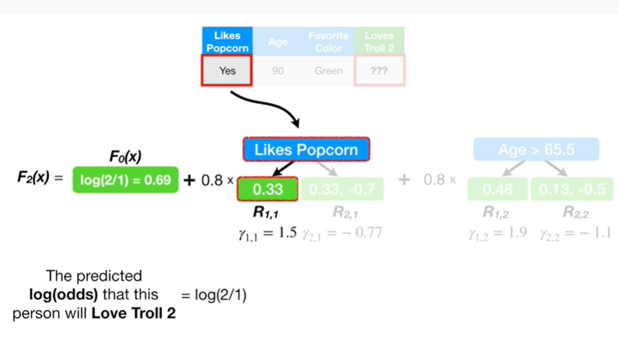

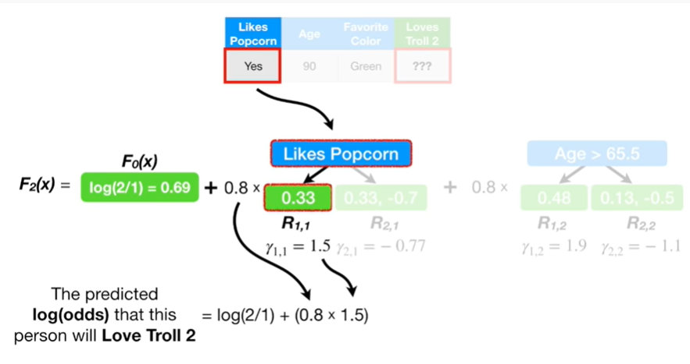

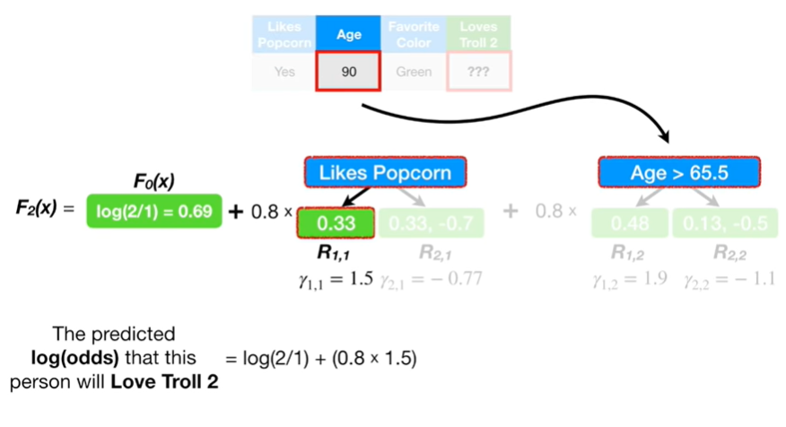

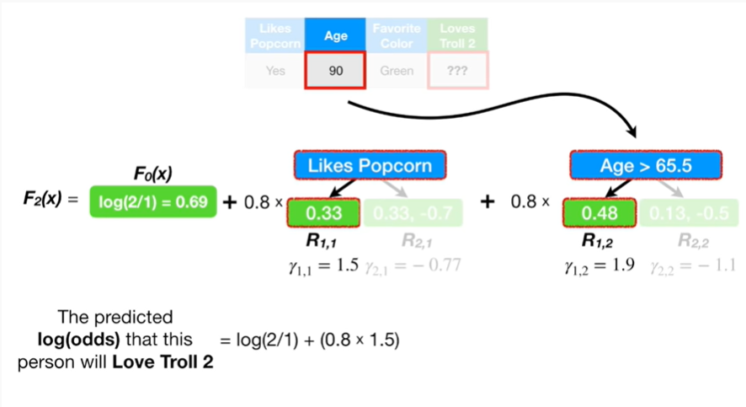

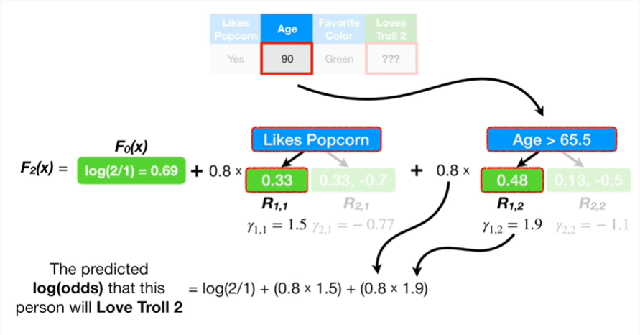

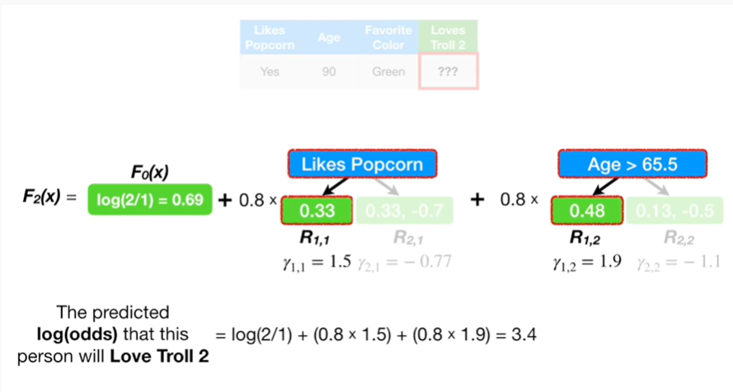

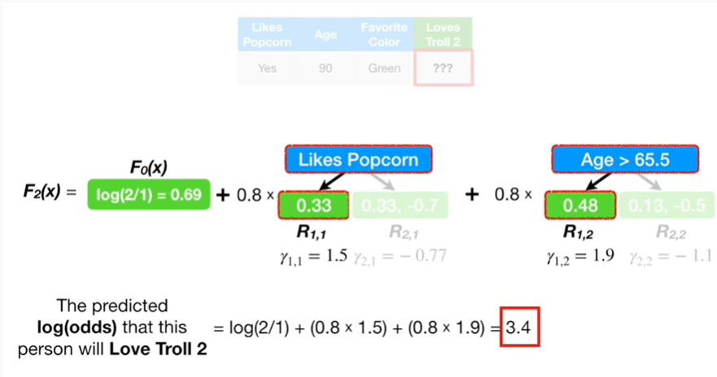

Predicted log-odds that this person will love troll 2 equals 3.4.

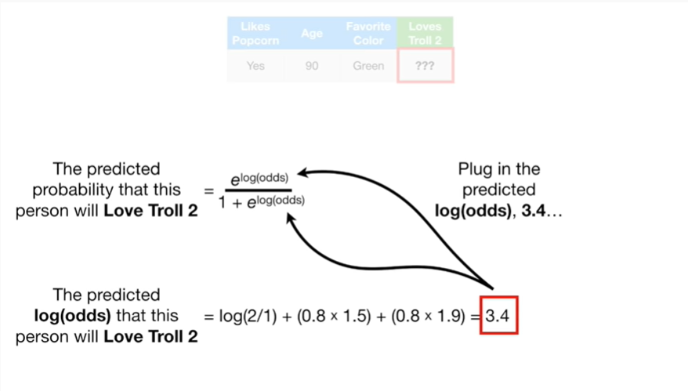

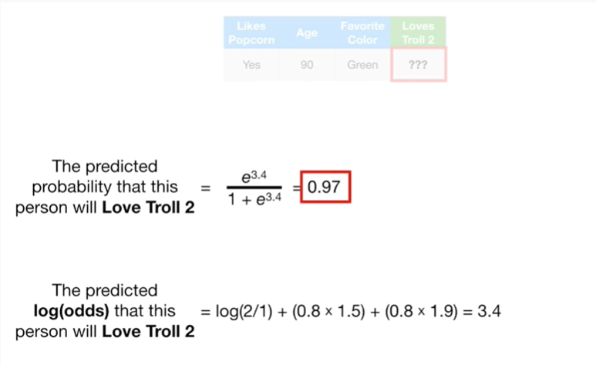

The predicted probability that this person will love troll 2 equals 0.97.

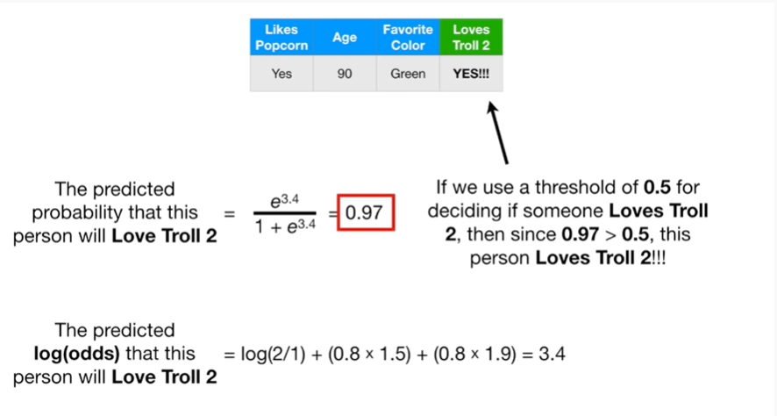

If we use a threshold of 0.5 for deciding if someone loves troll 2, then since 0.97 is greater than 0.5 this person loves troll 2.



Triple bam !!!

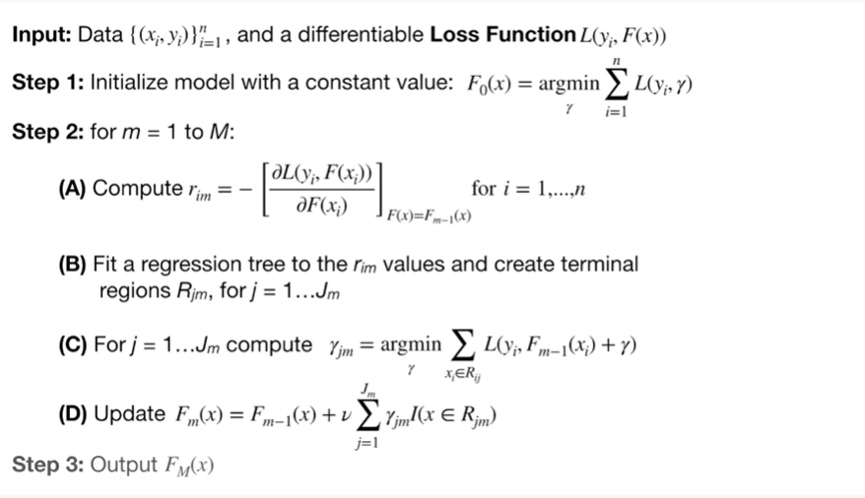

Holy frickin smokes we made it through this whole algorithm, I can't believe it, we've done it for regression and now we've done it for classification.